Varun Khadayate

A016

B. Tech (CsBs) TY

# Aim

 To install Windows 10/Kali Linux on VirtualBox and to make Windows 10/Kali Linux and Ubuntu communicate with each other

# Software Used

Windows 11, Chrome, Oracle VM, Ubuntu, Windows10.

# Steps to install Windows 10 in Oracle Virtual Box/Machine

## Visit Microsoft windows 10 Software Download official Website Link: <https://www.microsoft.com/en-in/software-download/windows10>

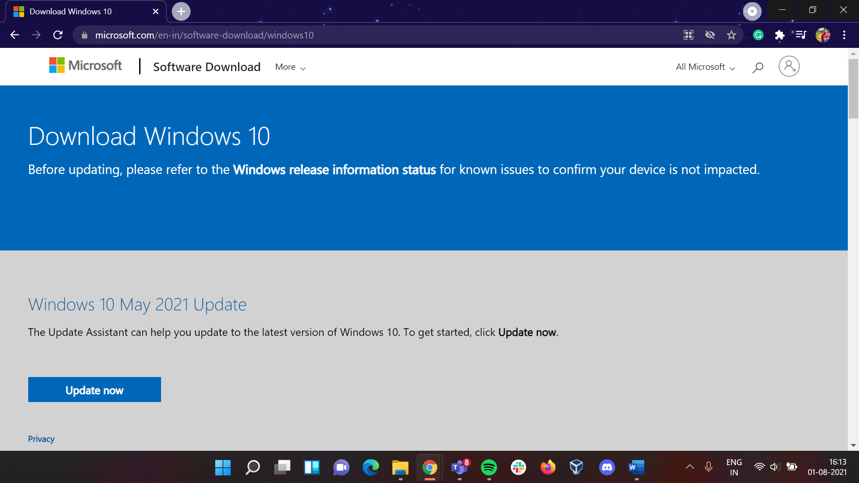

## Here we will be downloading the Windows 10 Installation Media to download that click on **Download tool now** button below that and the download will start.

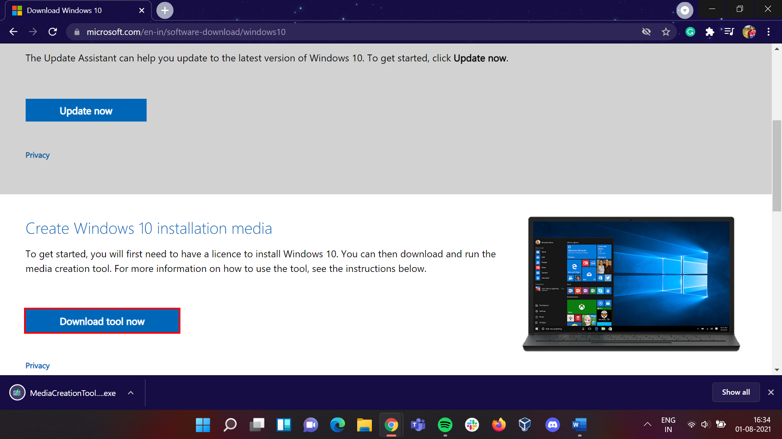

## Once the tool named as “MediaCreationTool21H1” is downloaded open that and follow the below steps.

### Click on **Accept** button to proceed further

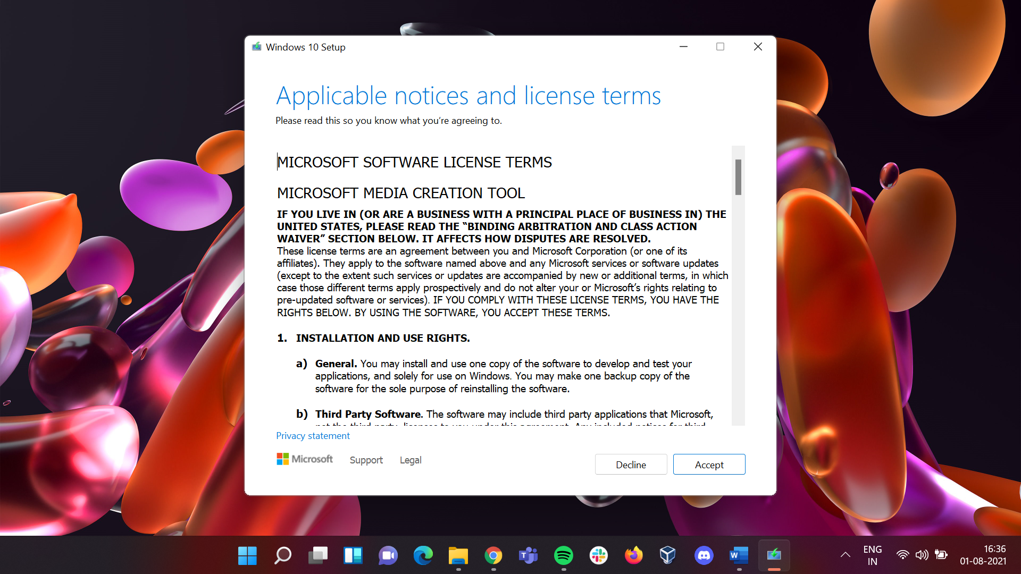

### Click on **Create installation media (USB flash drive, DVD, or ISO file) for another PC** and then click on **Next** Button to proceed further**.**

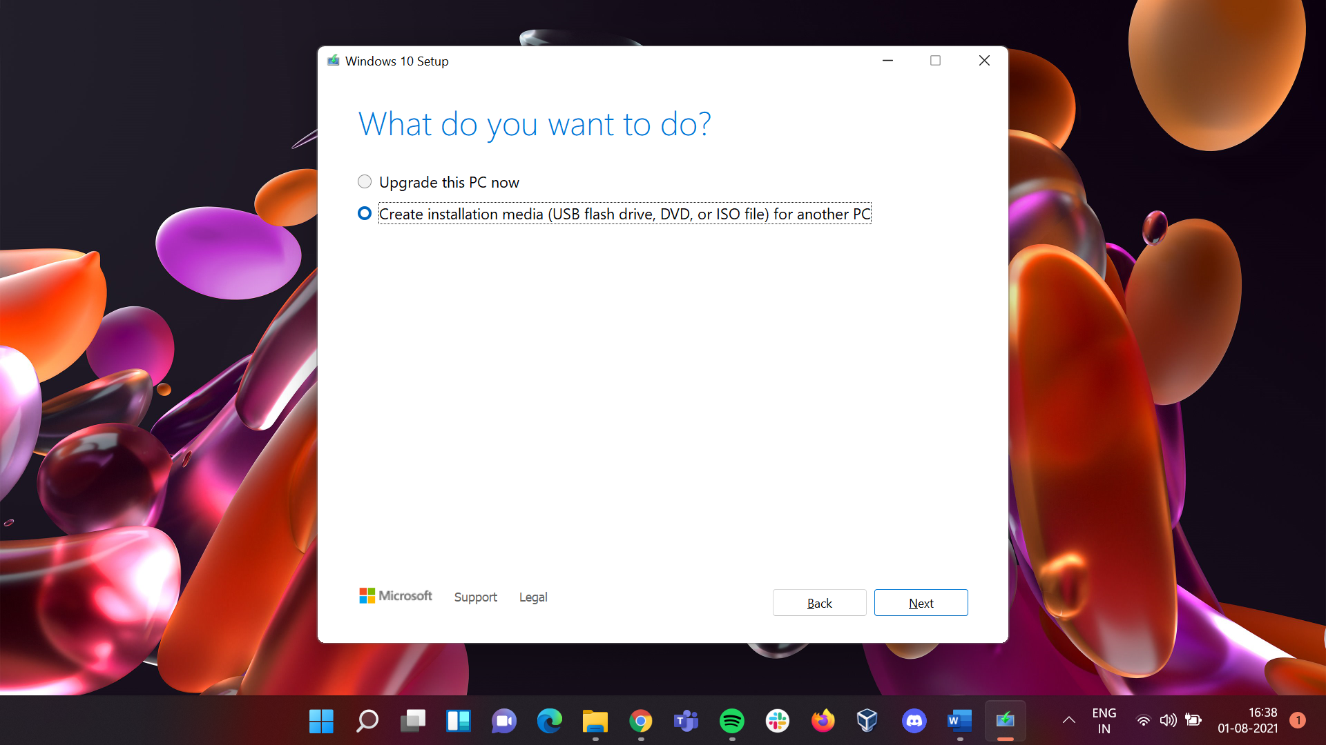

### Leave everything as default and then click on **Next** Button to proceed further**.**

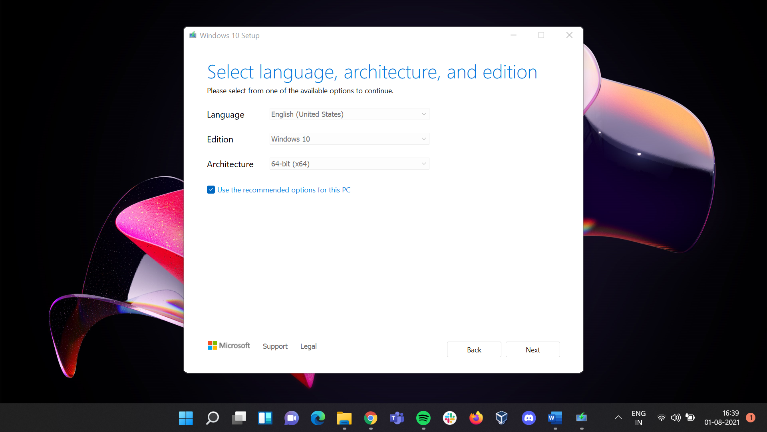

### Click on **ISO File** and then click on **Next** Button to proceed further**.**

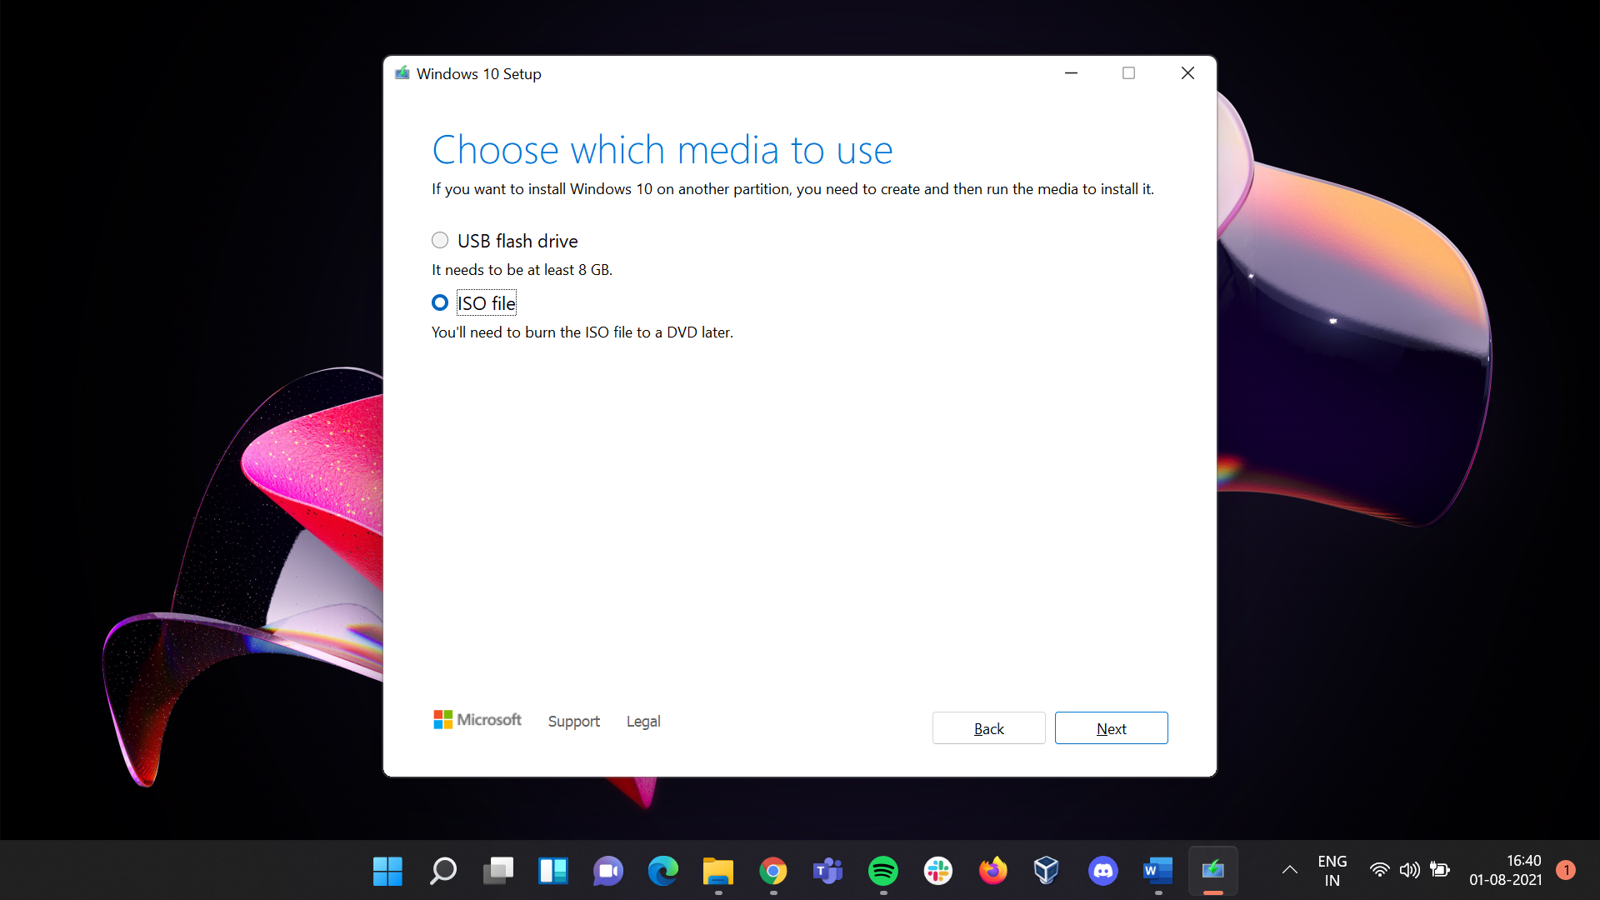

### Save it to a preferred location in my case its **“D:\SETUP SOFTWARES”**

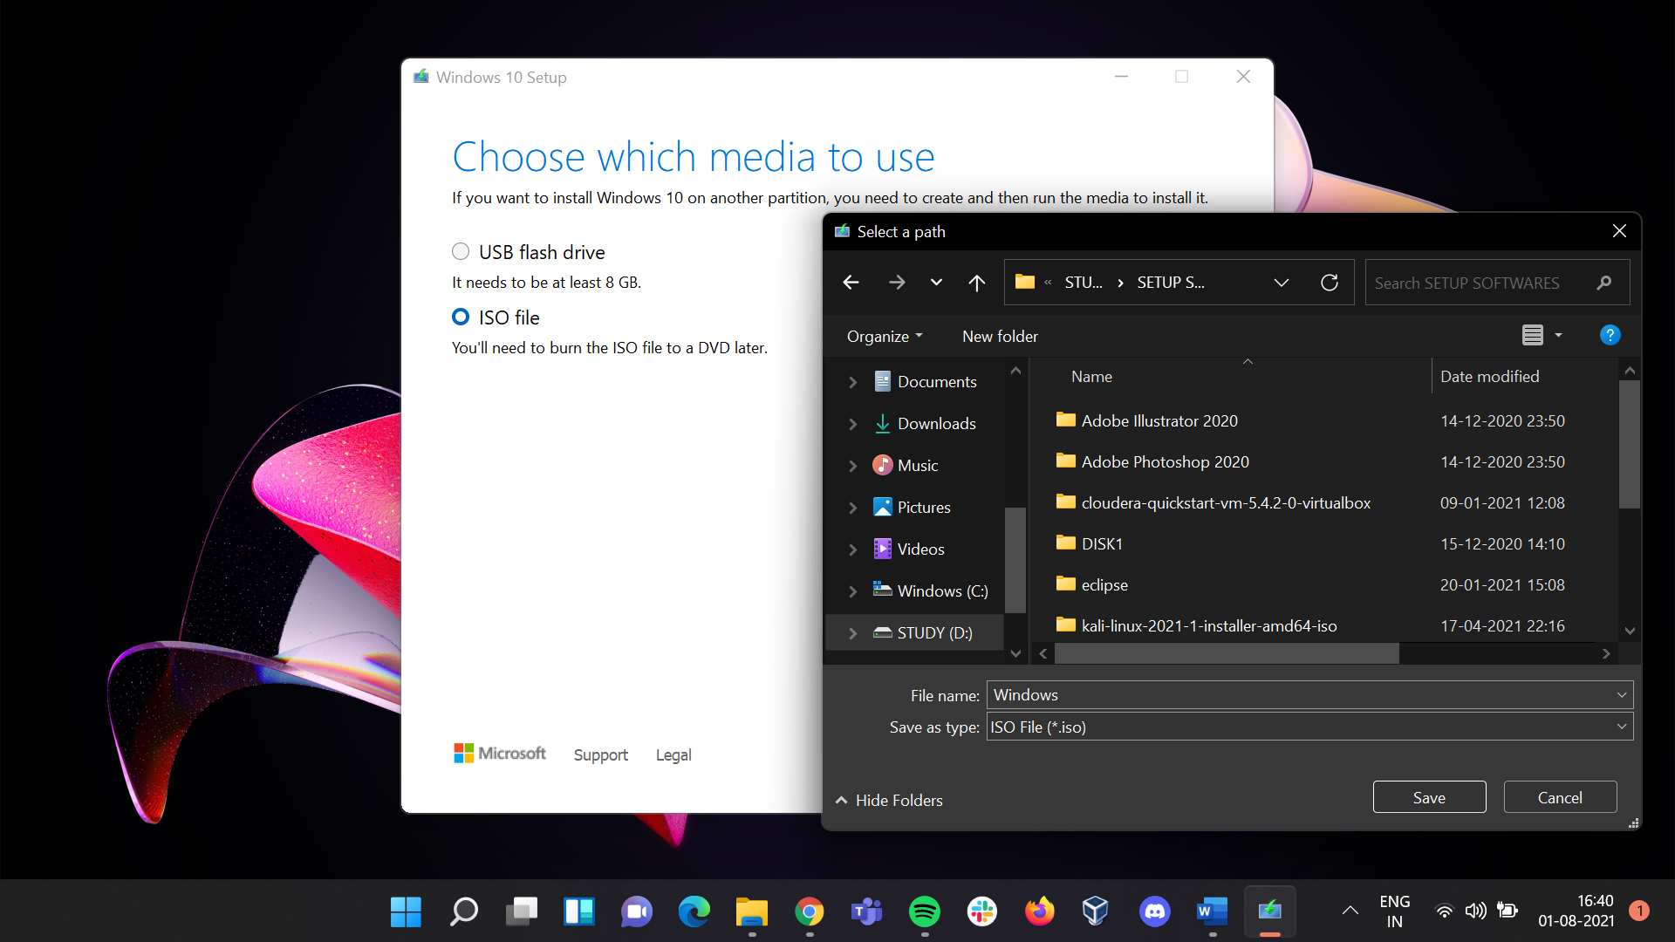

### The downloading process will start and will take 2-3 hours to download it.

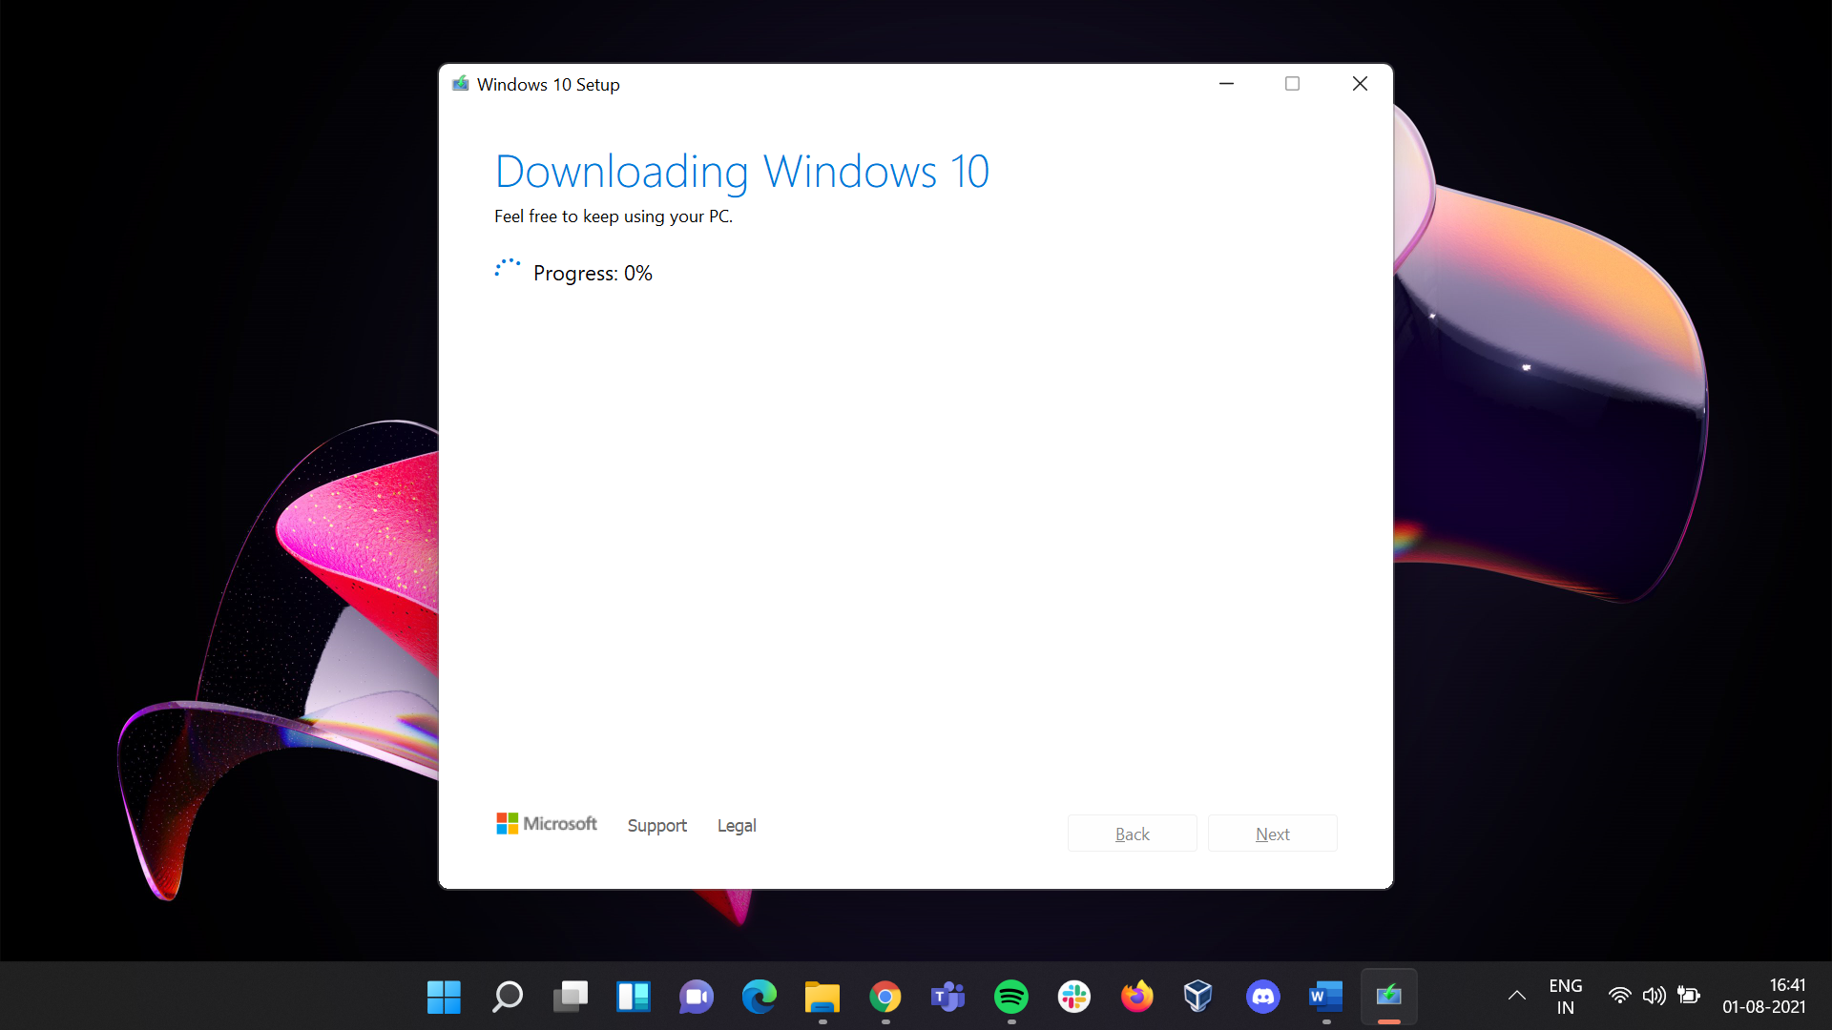

## Once download is completed open the Oracle VM

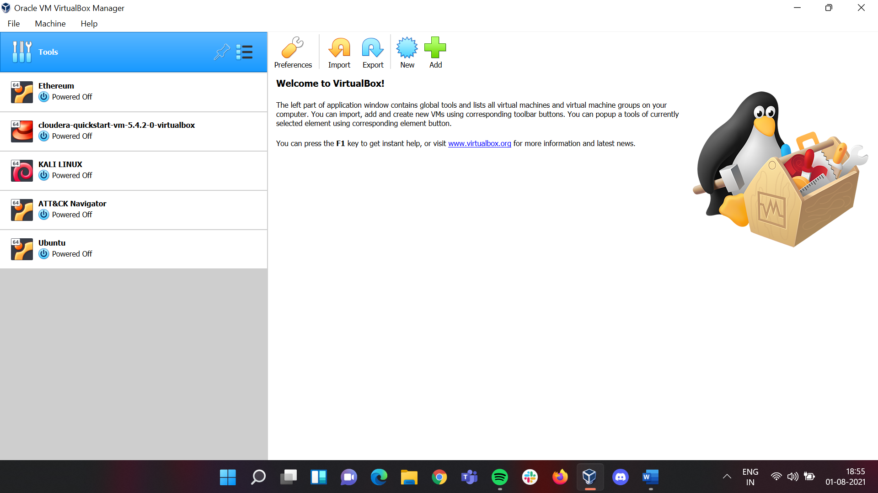

## Under **Tools** click on **New**

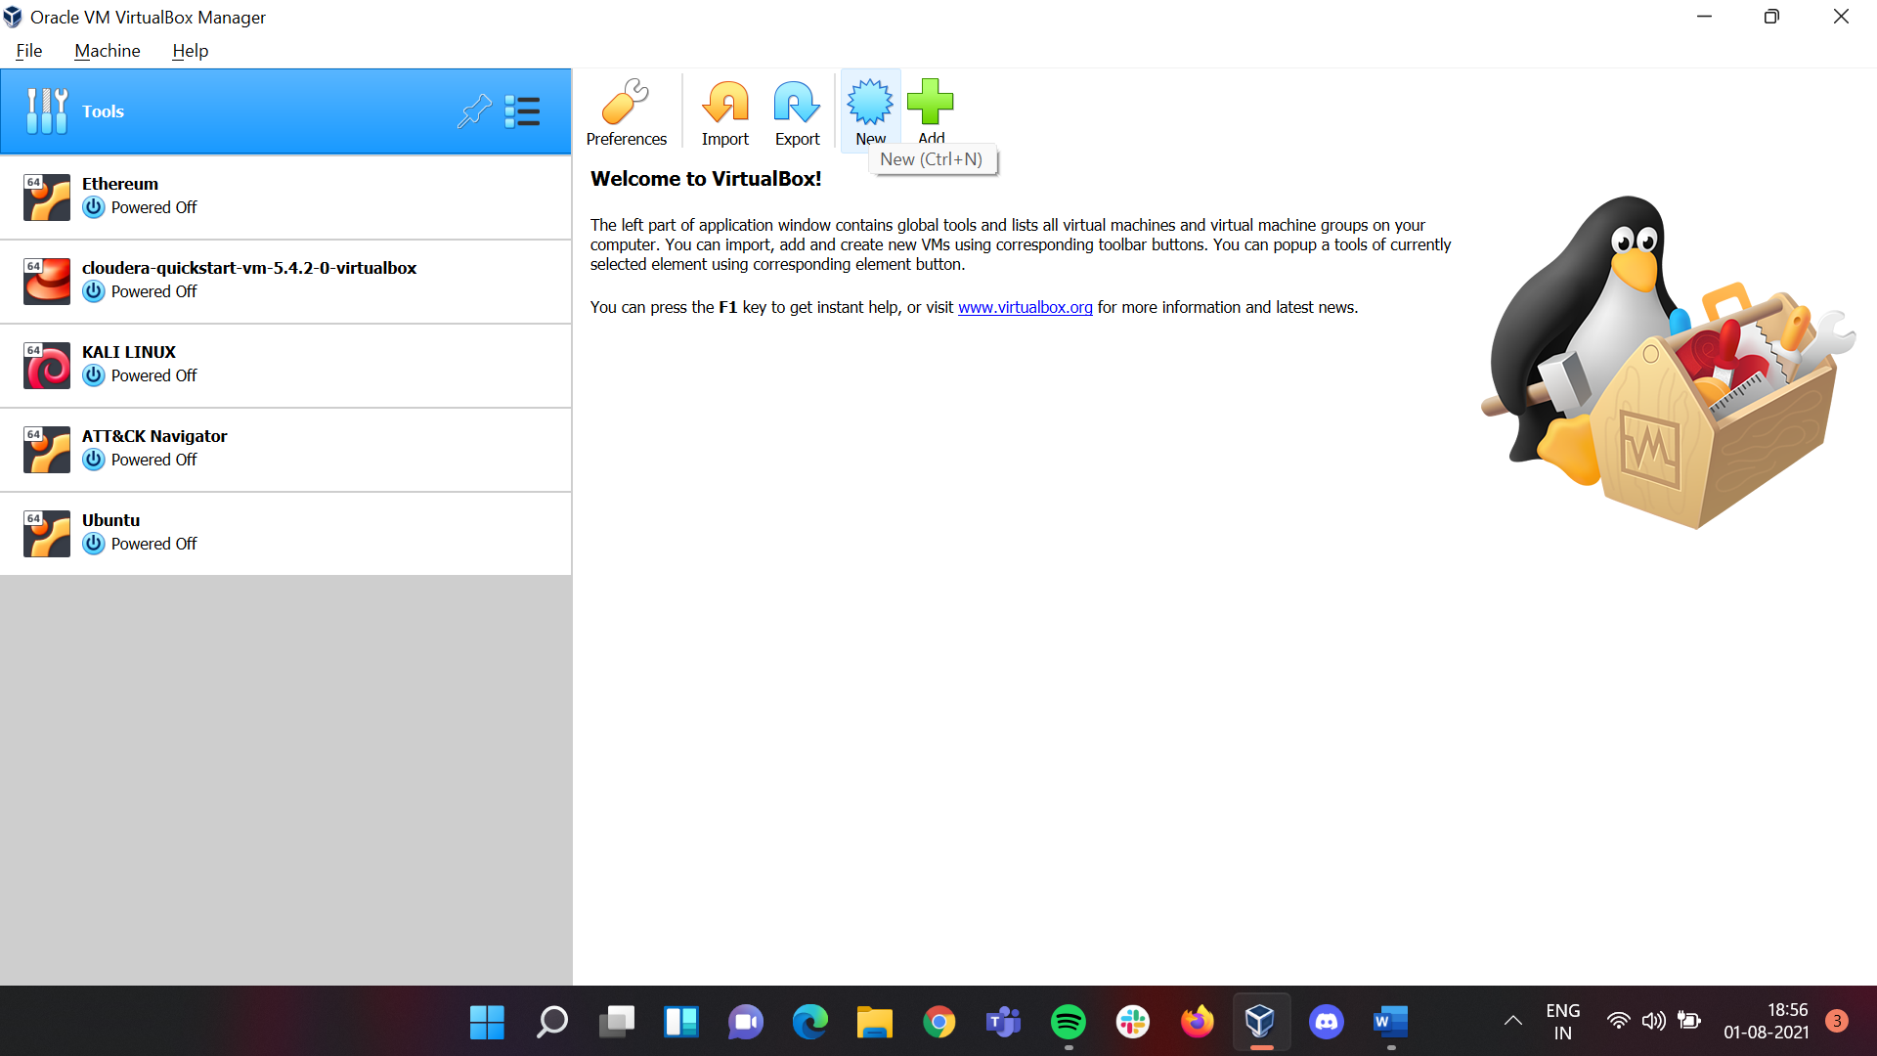

## In **Name and Operating System** Sub-window under **Name**, name it as “**Windows**”. And click on **Next.**

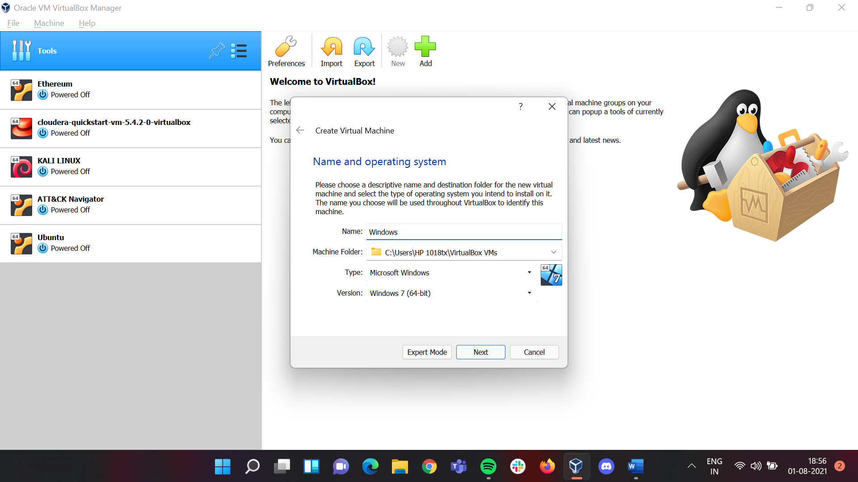

## In **Memory Size** Sub-window set the memory size up to the **green bar** which in my case will be at **5265 MB**. After doing that click on **Next.**

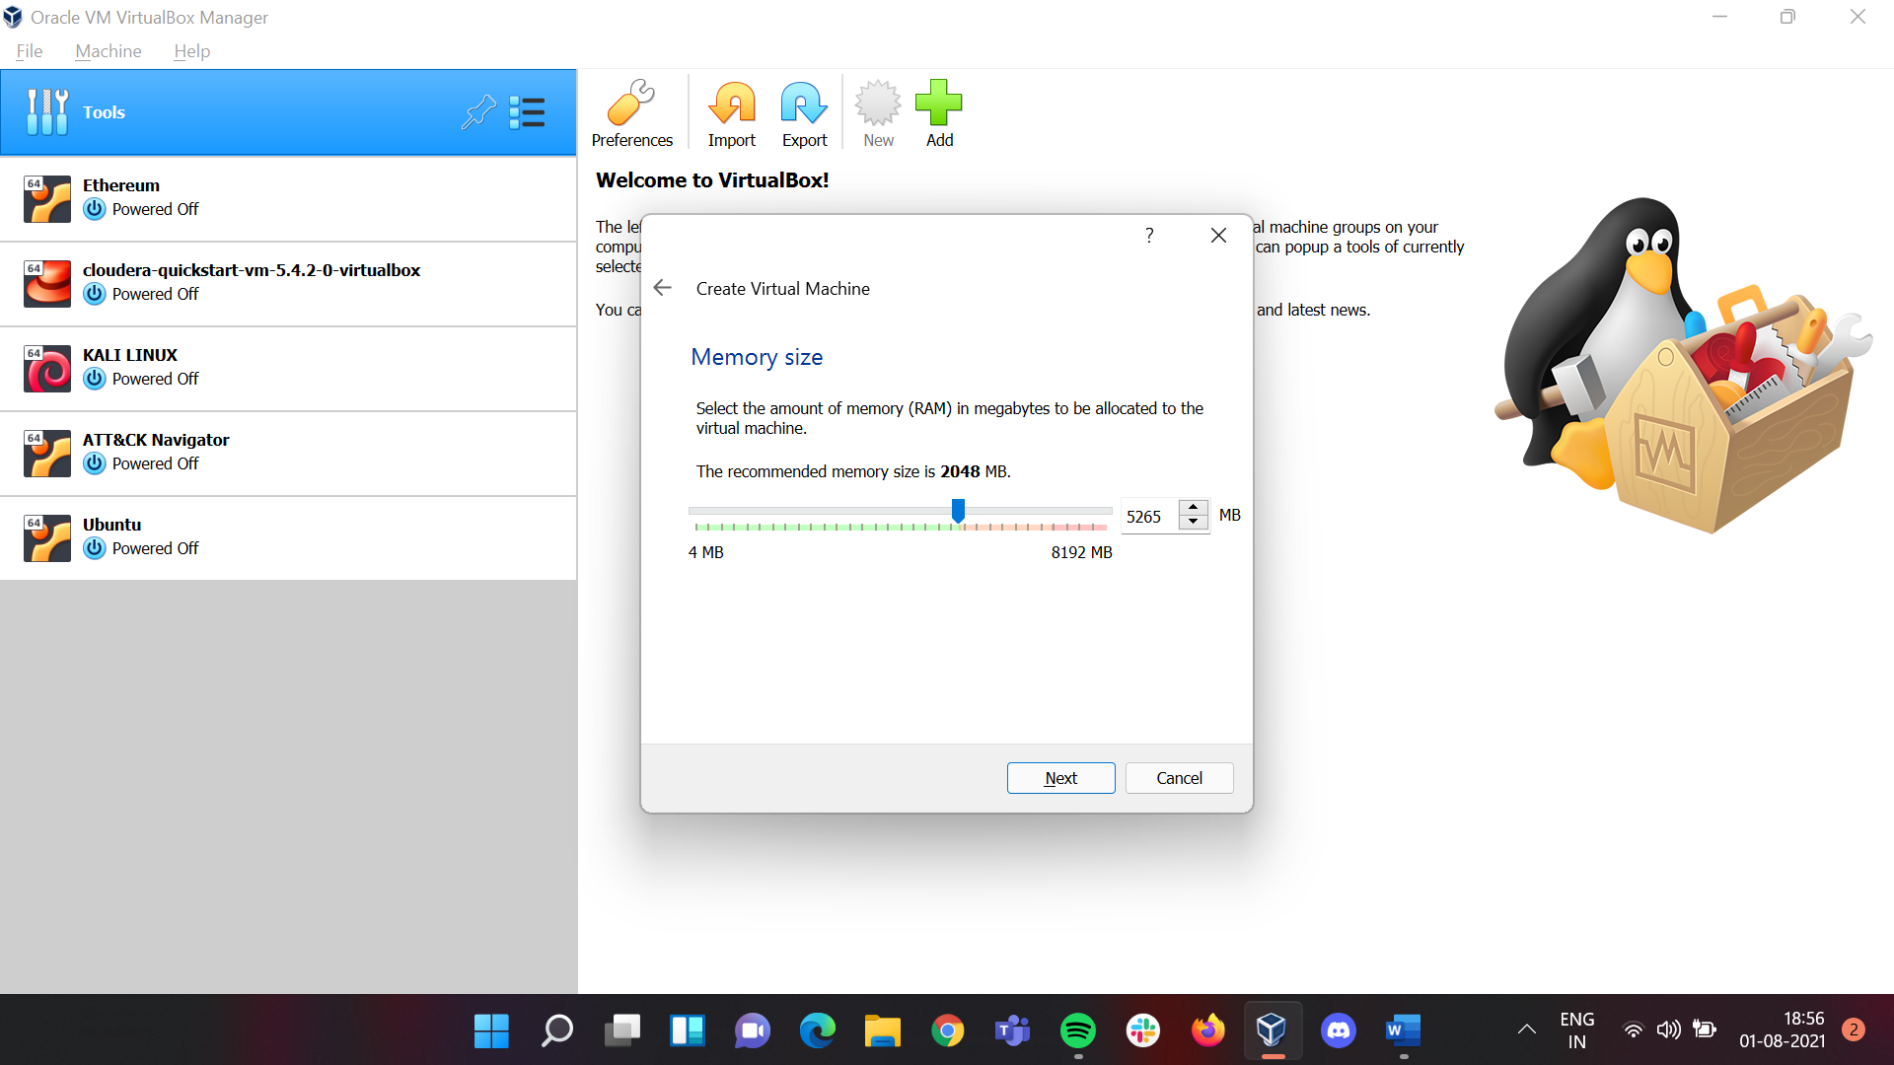

## Under **Hard Disk** Sub-window leave it as default and click on **Create.**

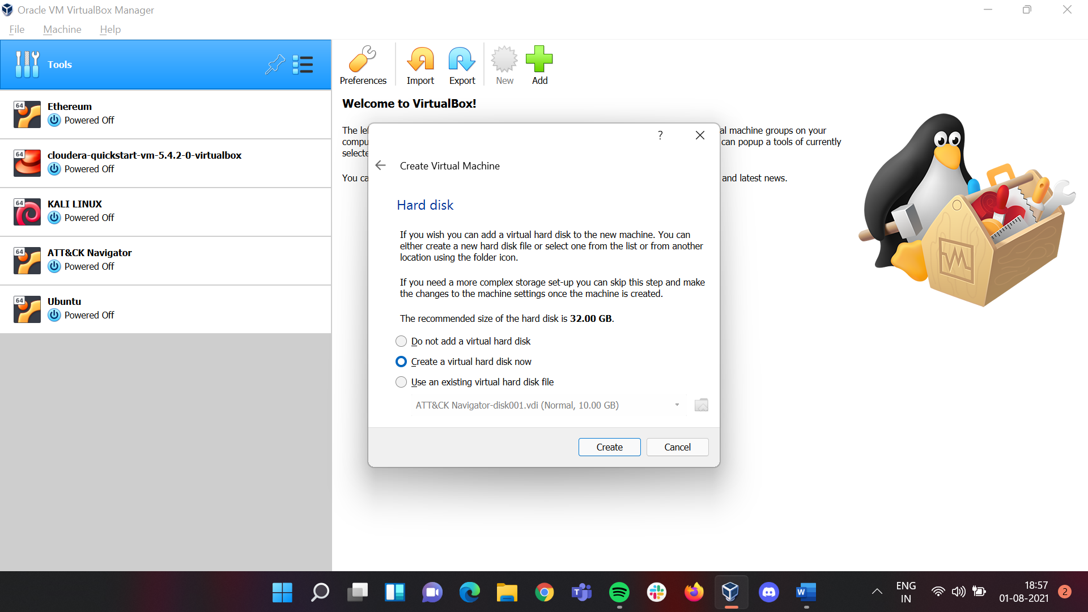

## Under **Hard Disk File Type** Sub-windowclick on **VDI (Virtual Disk Image).** After that click on **Next.**

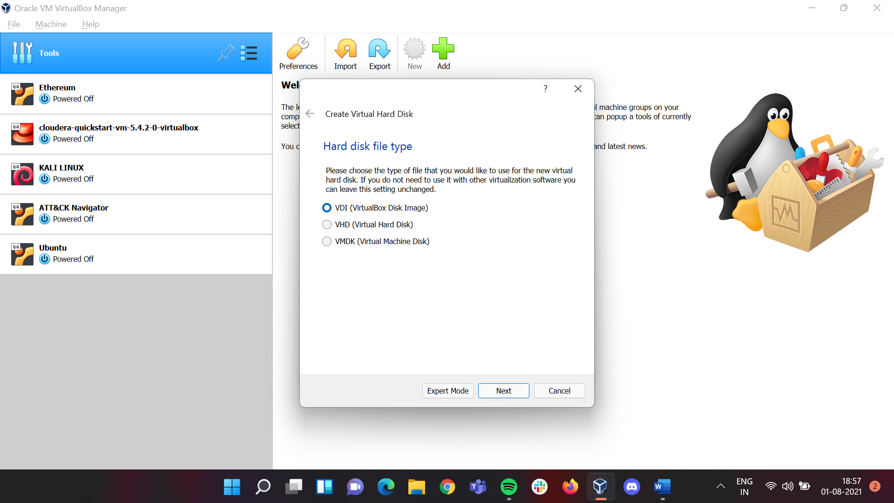

## Under **Storage on physical Hard Disk** Sub-Window click on **Dynamically Allocated**. After that click on **Next.**

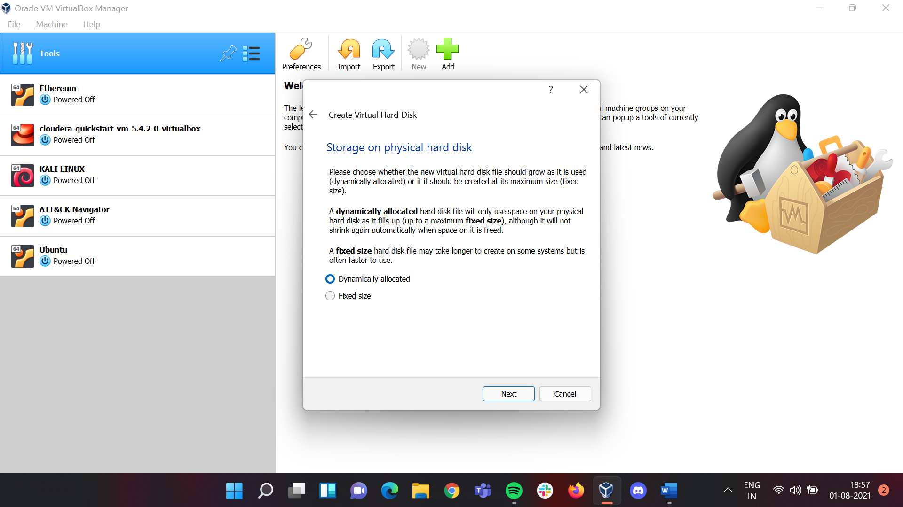

## We are now at the last step. In the **File location and Size** Sub-Window change the **memory size** to **50.00 GB.** After that click on **Create.**

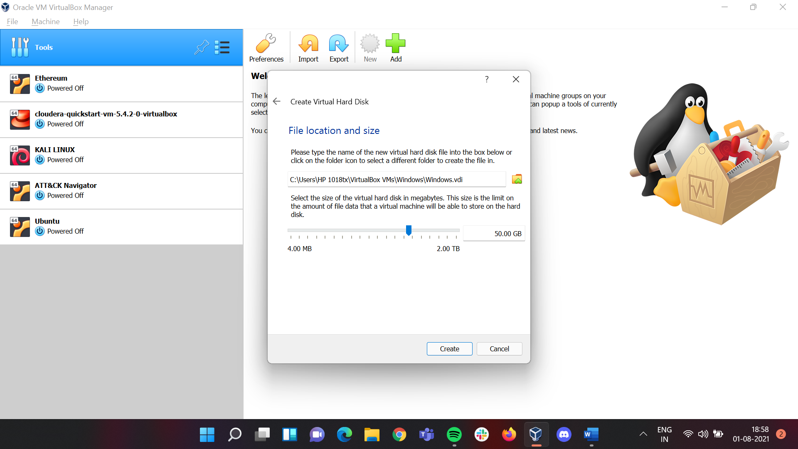

## Now **Windows** has been added to **Oracle VM**.

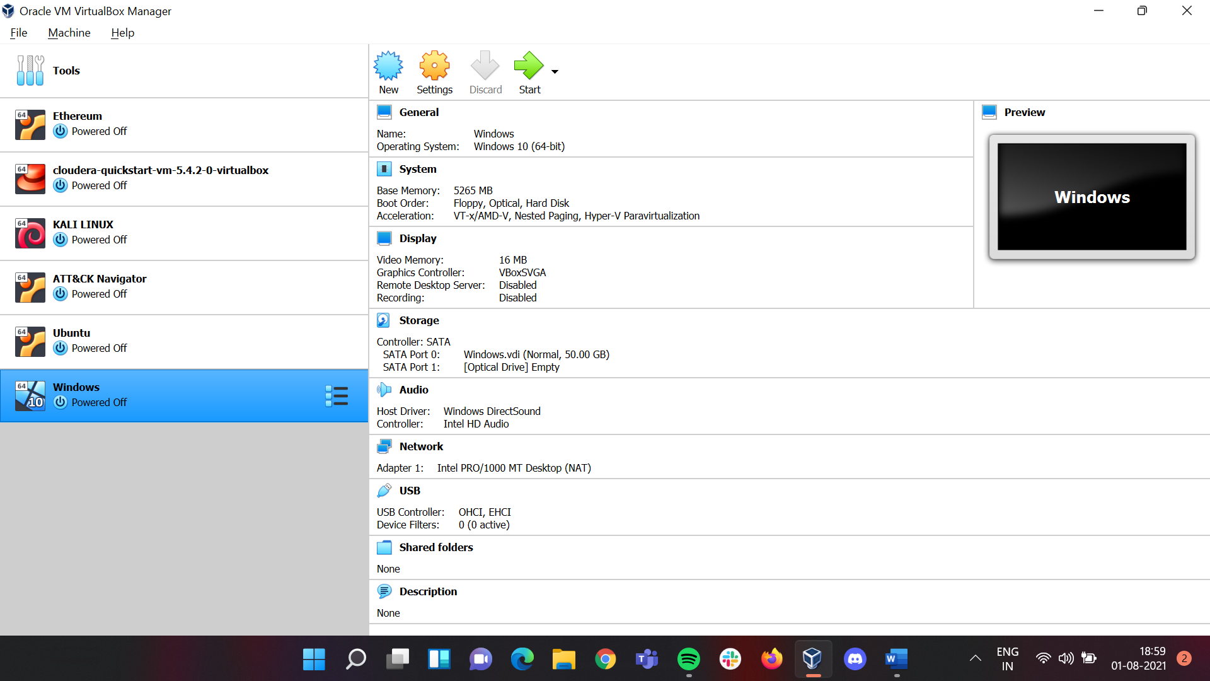

## Here click on **Settings**

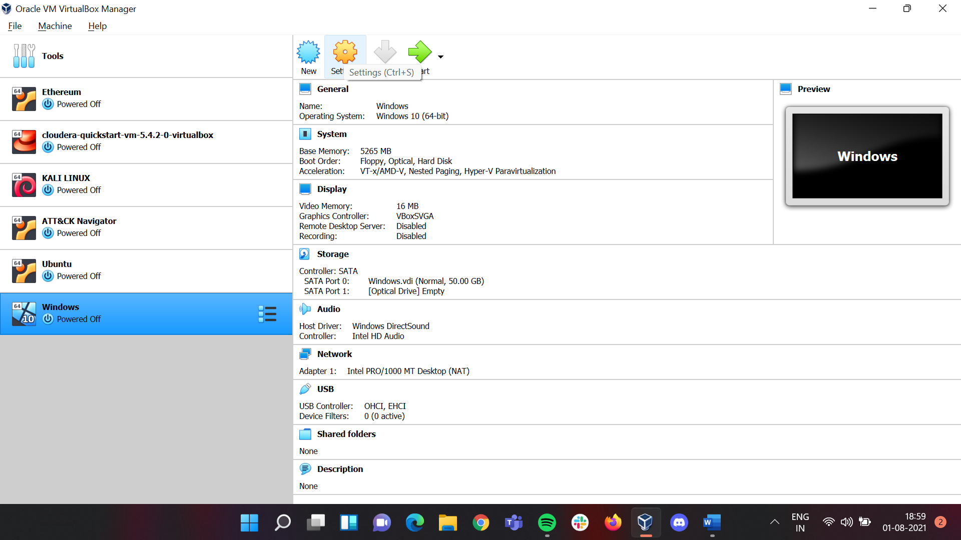 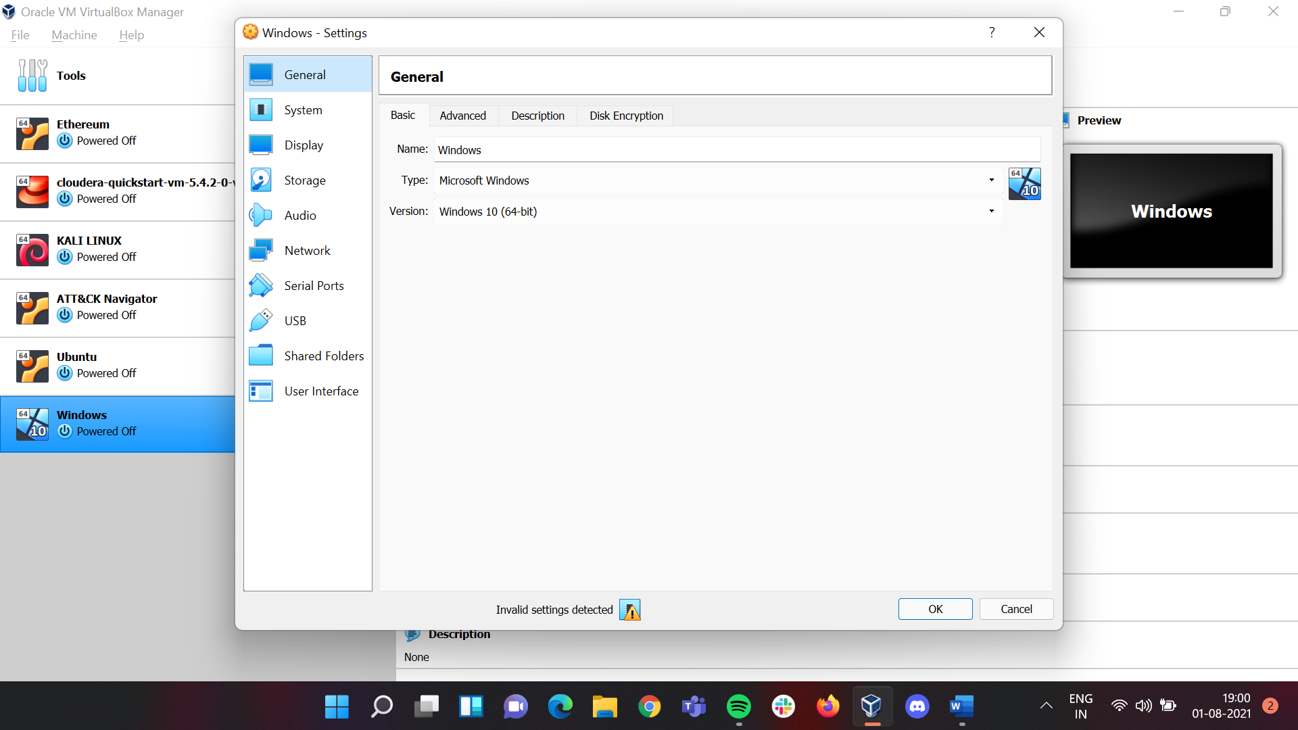

## On the **Settings** Sub-window under

### **General** click on **Advanced** and change **Shared Clipboard** and **Drag'n'Drop** from **Disabled** to **Bidirectional**.

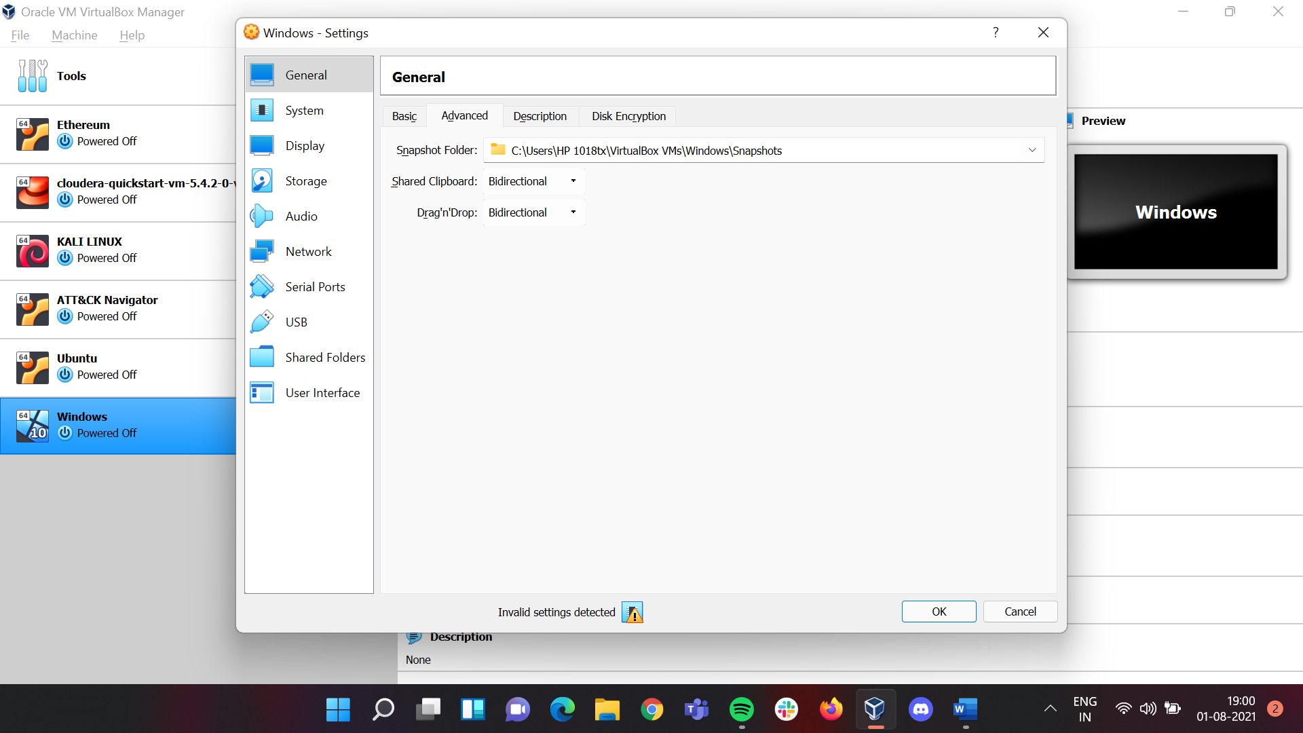

### **System** click on **Processor** and change **Processor(s)** from **1 CPU** to **4 CPU.**

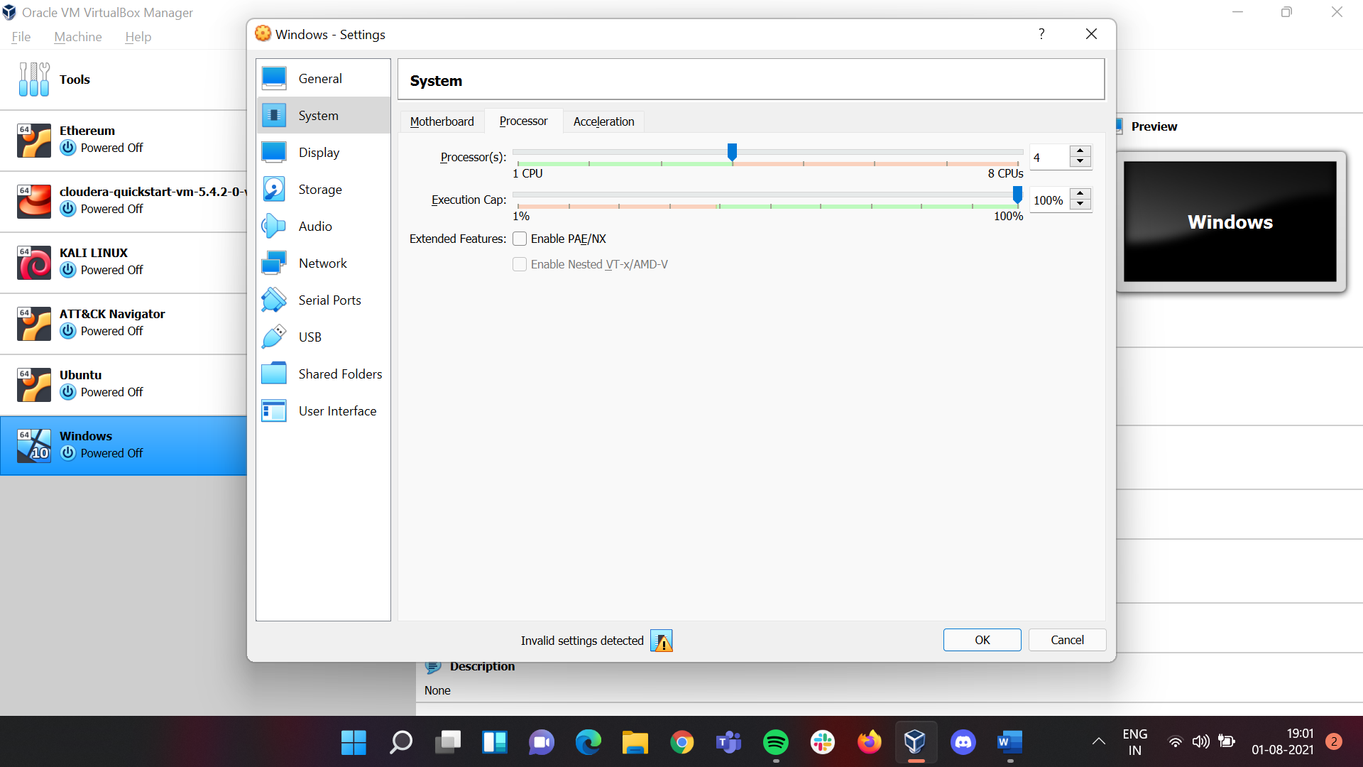

### **Display** leave it as default

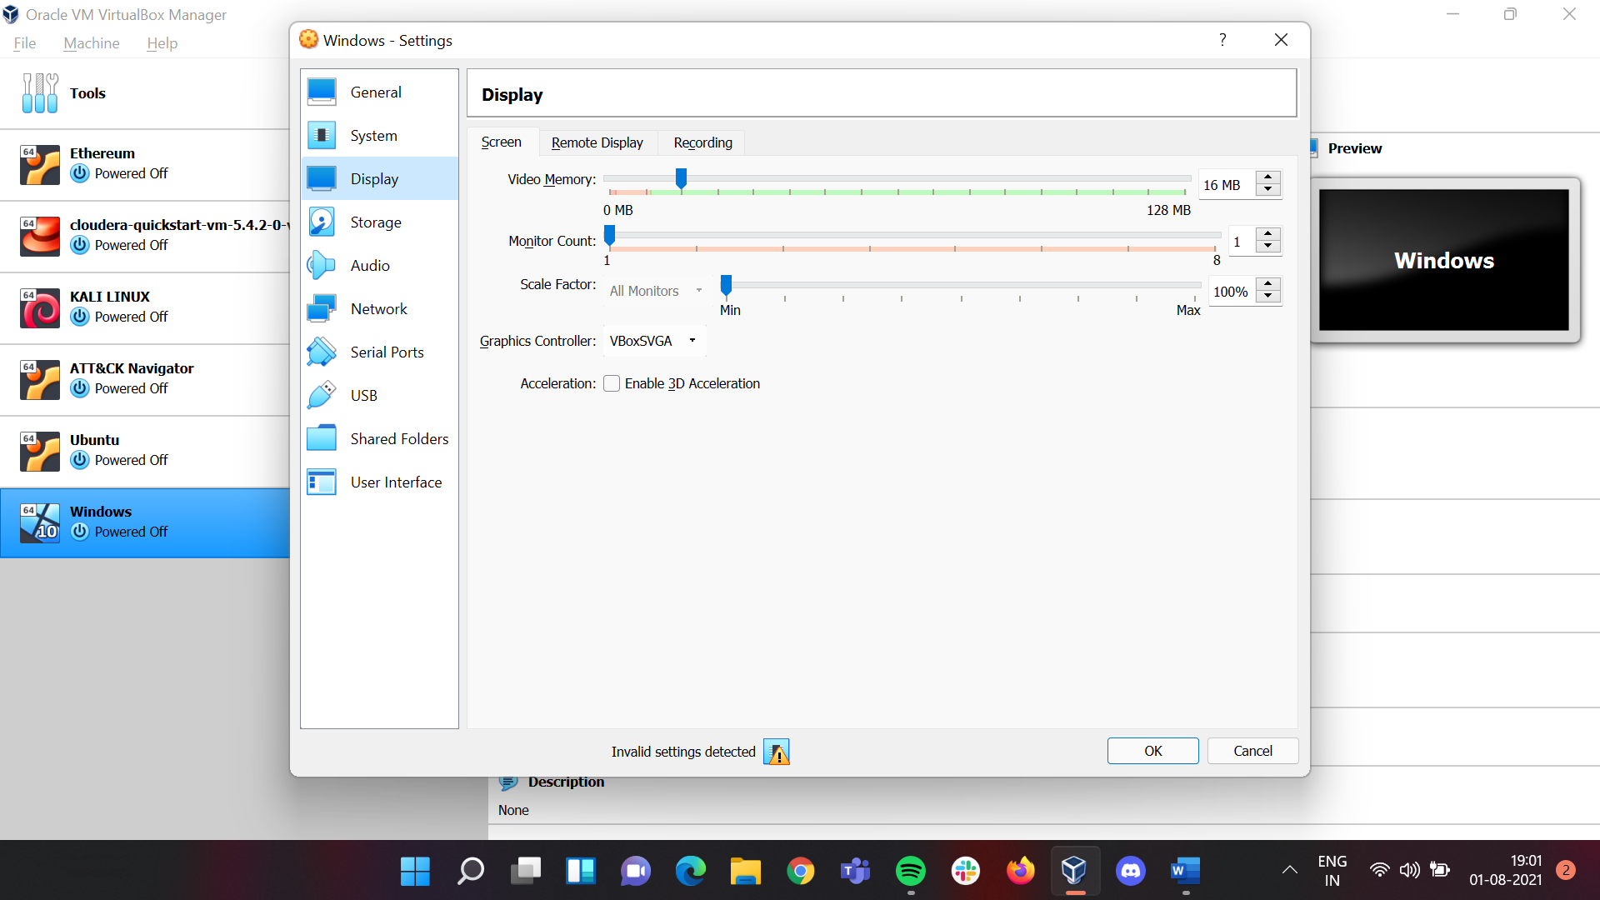

### **Storage** click on **Controller : SATA – Empty** here we have to add the **ISO** file we downloaded for that click on **the disk icon** then on **Choose a disk file** and choose the ISO file

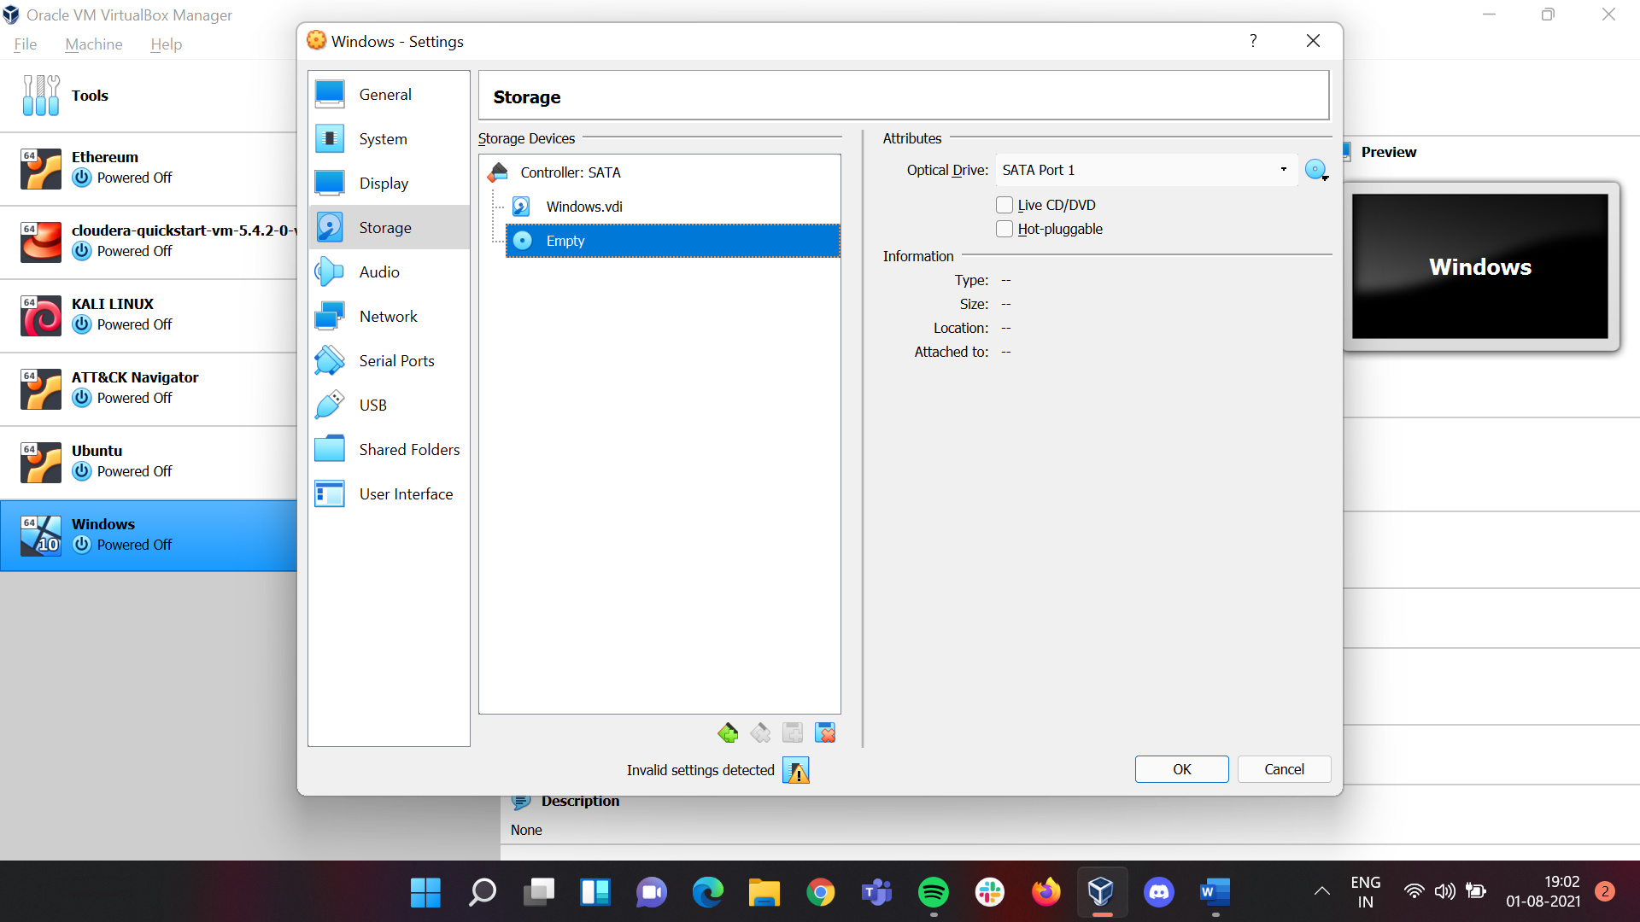 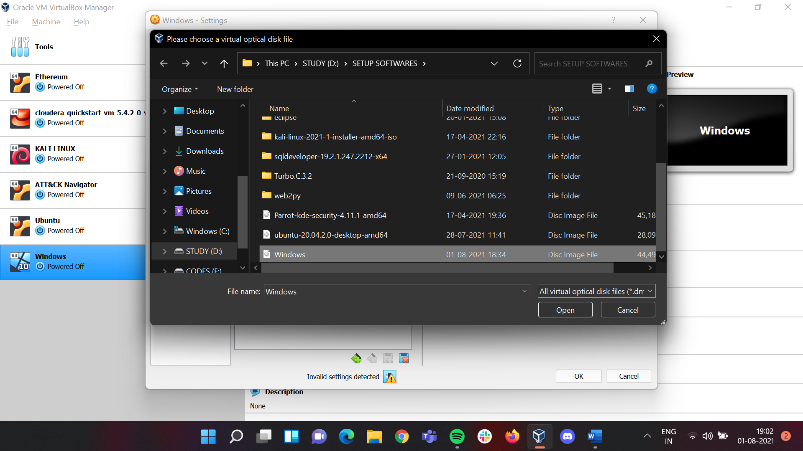

### Once added click on **Ok** and then the main page will open.

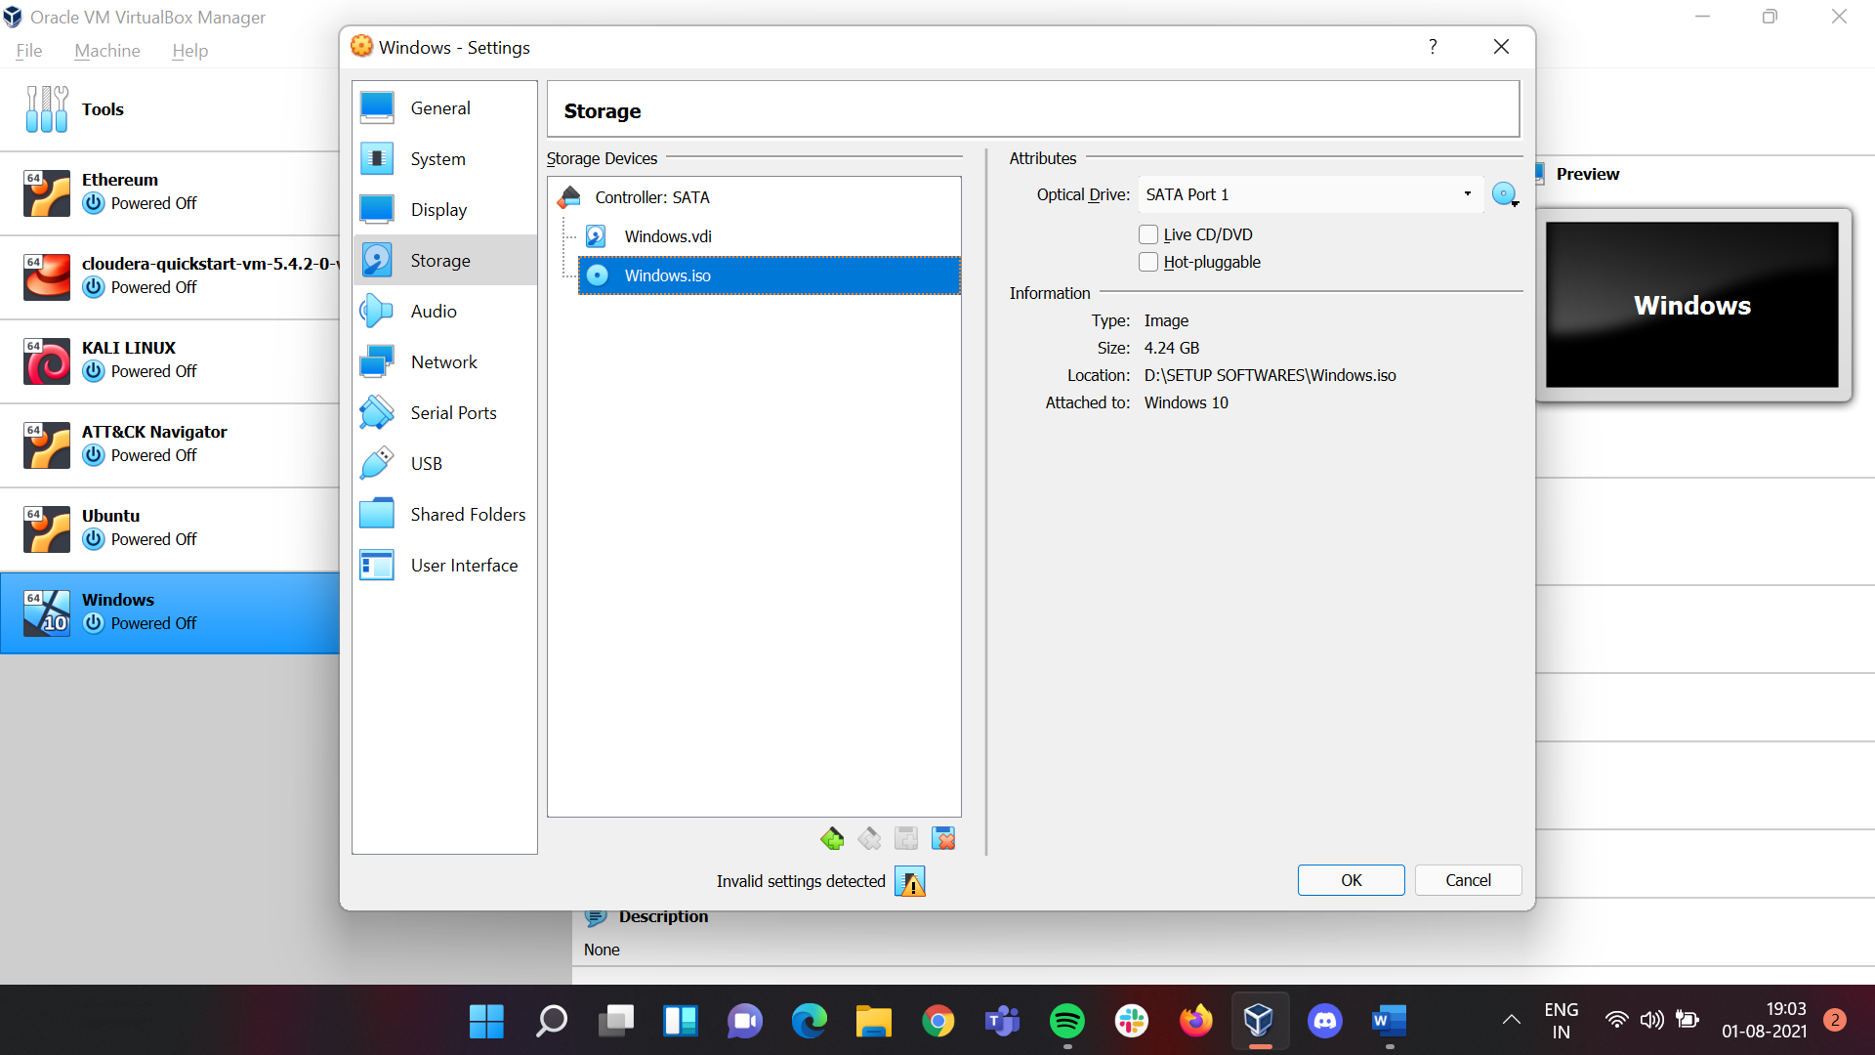 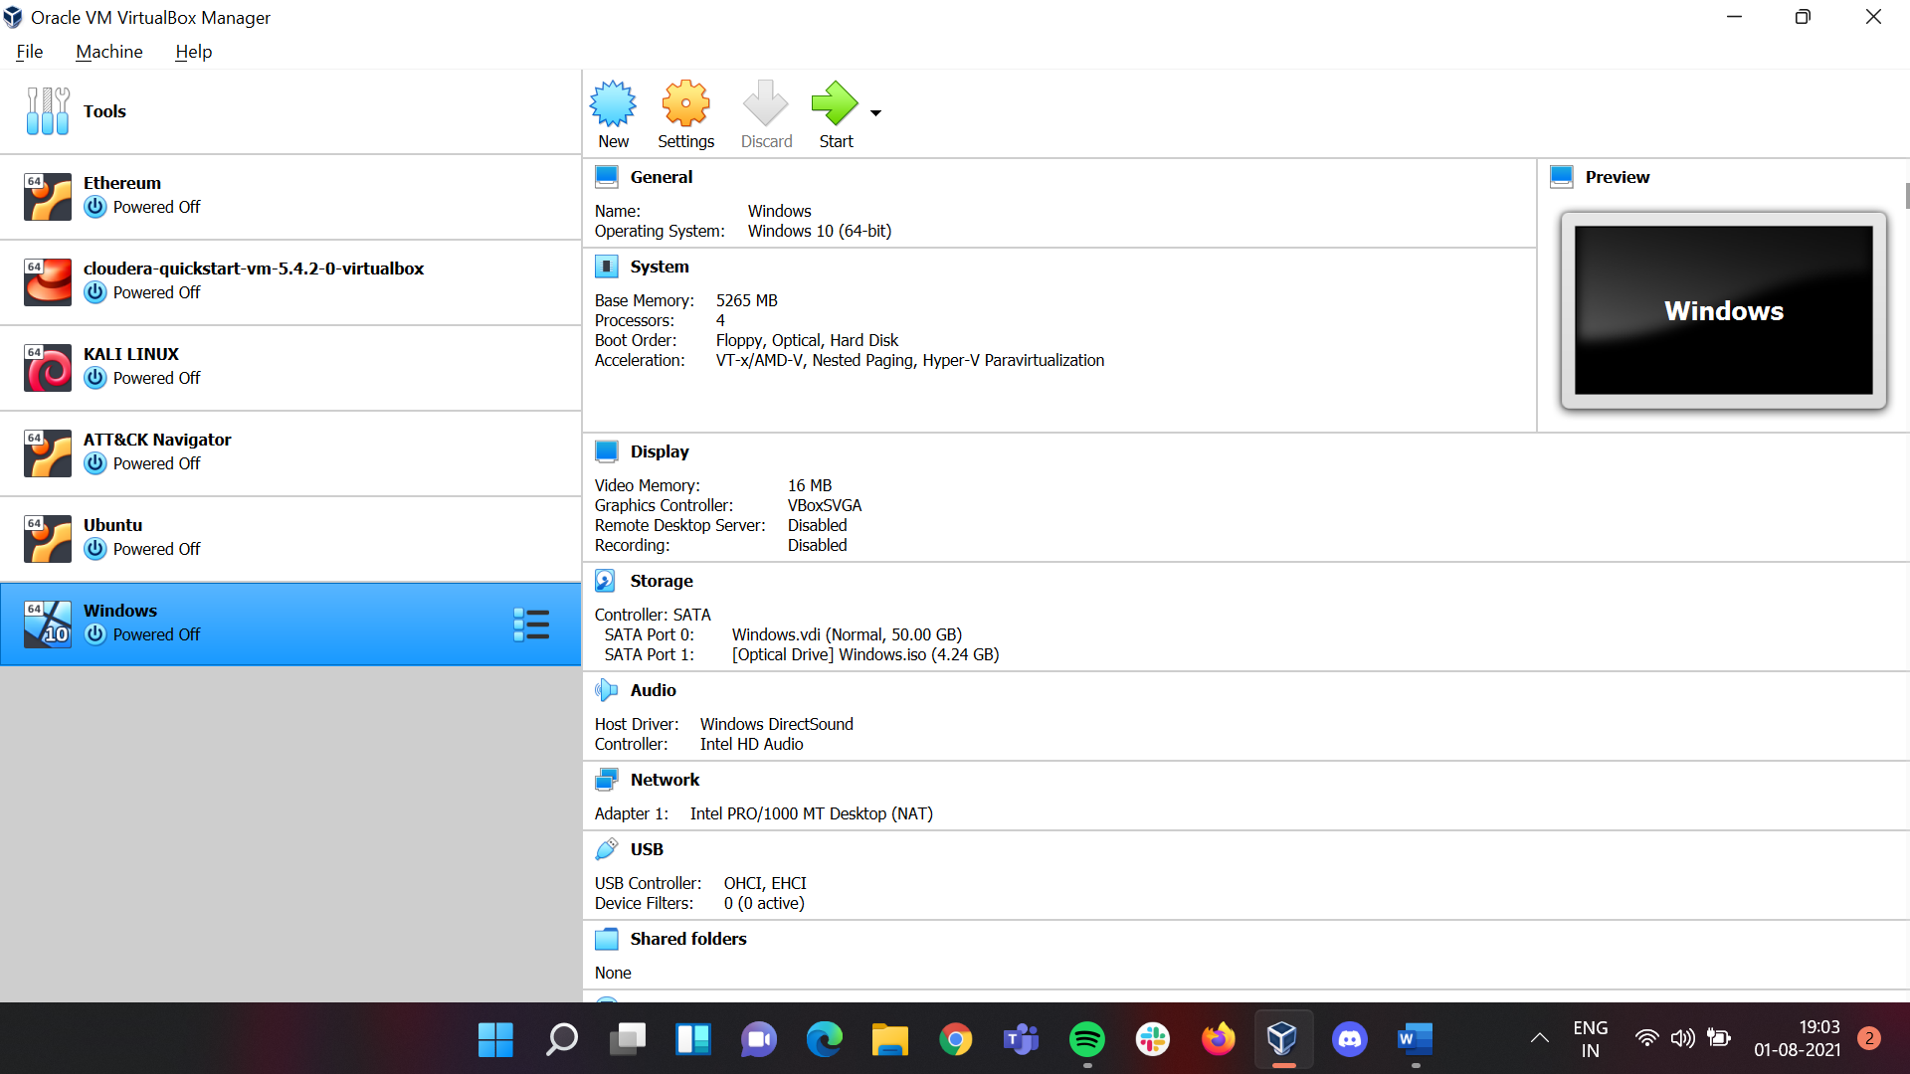

## Once the above steps are followed click on **Start.**

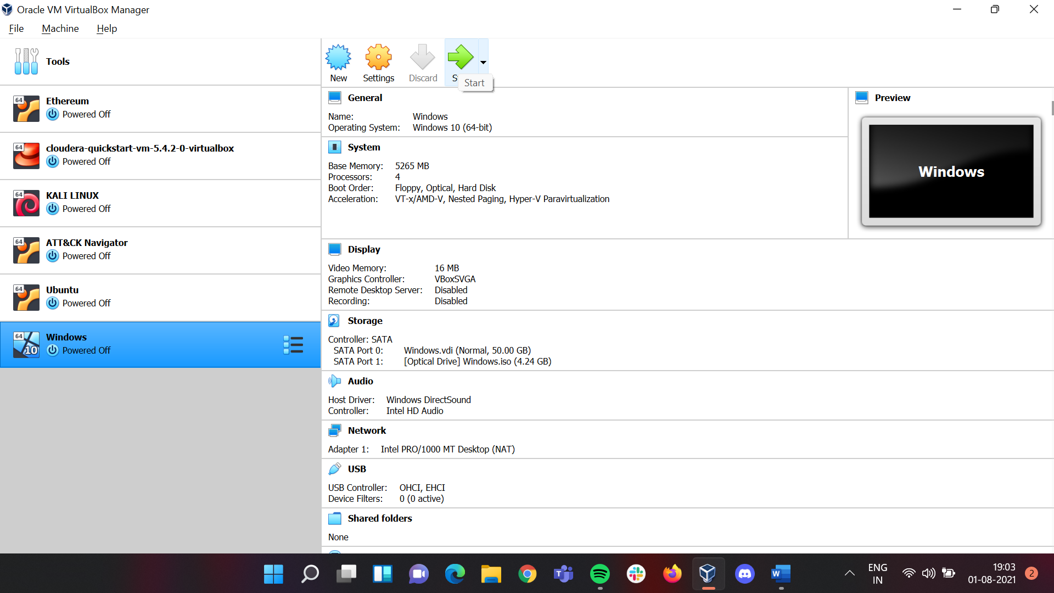

## Once clicking on **Start** a new window will open with Windows and follow the following steps

### Click on **Install Now** Button

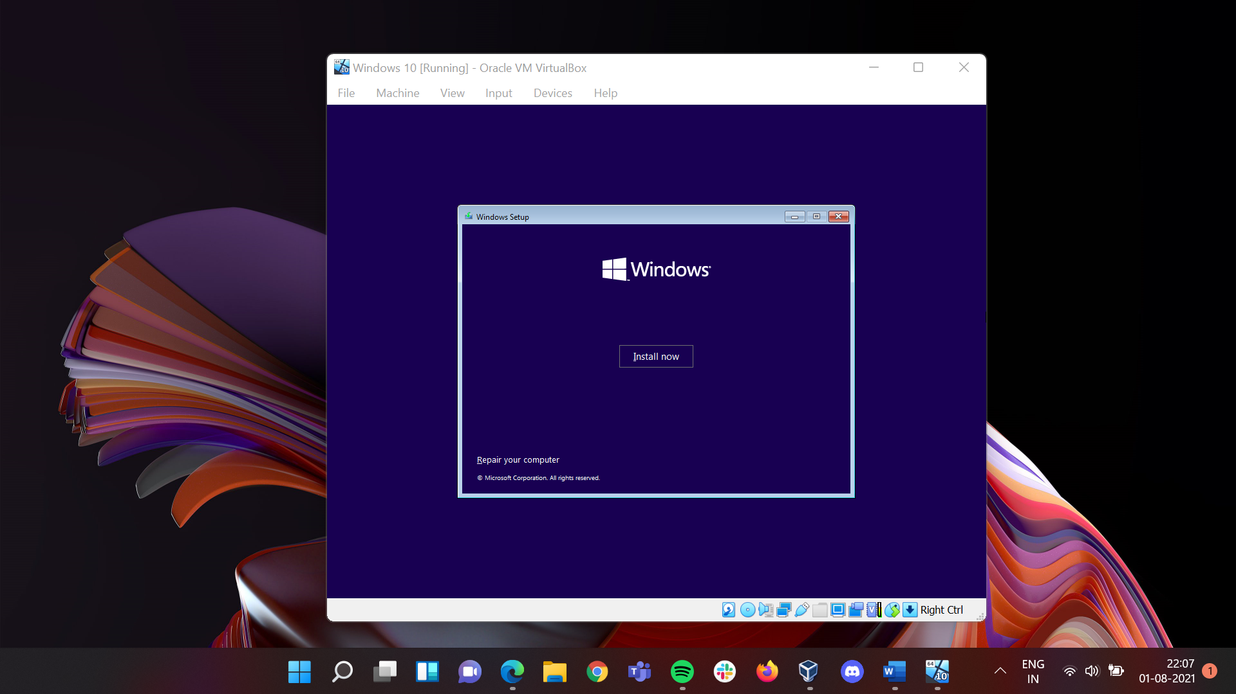

### Since we don’t have a product key click on **I don’t have a product key** to proceed further

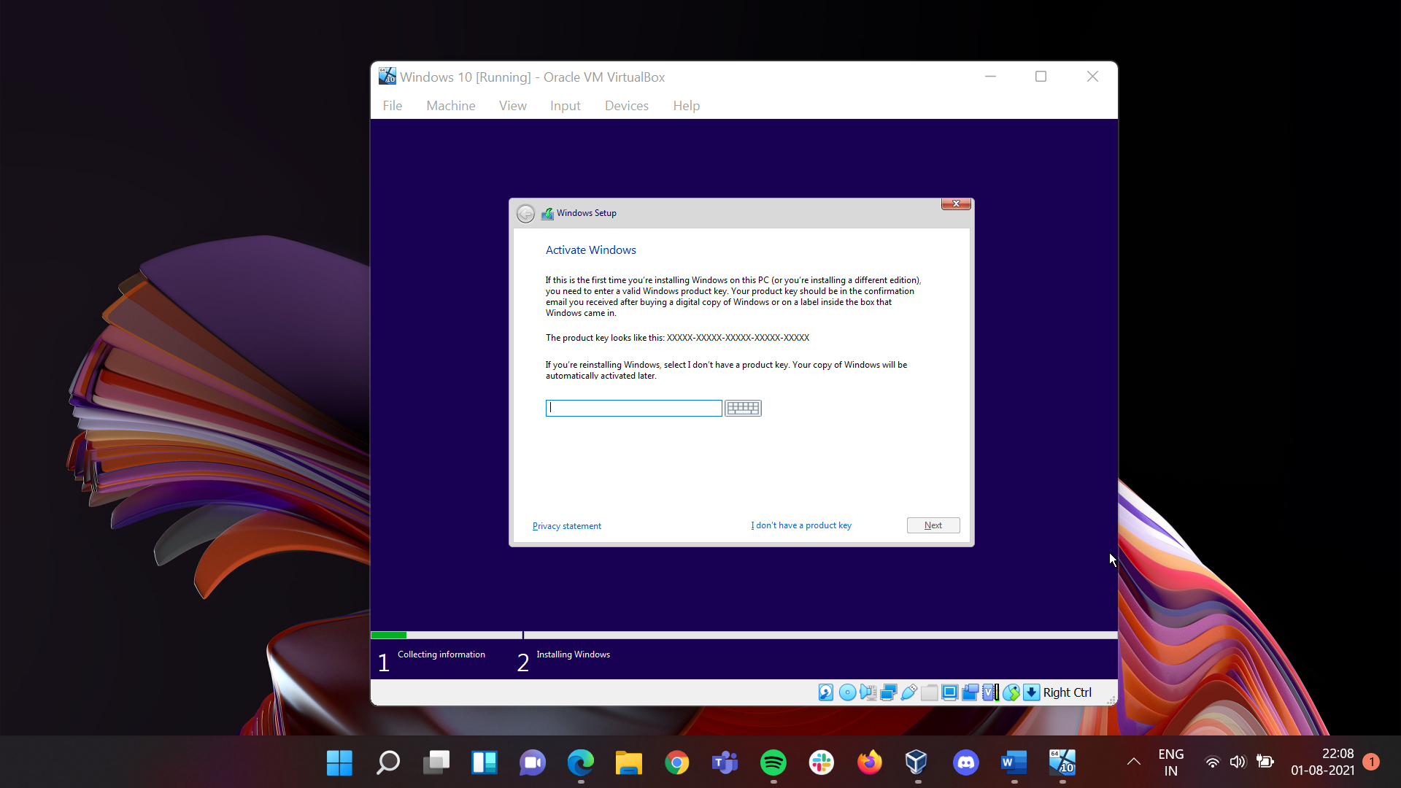

### Here click on **Windows 10 Pro** Edition and then click on **Next** to proceed further.

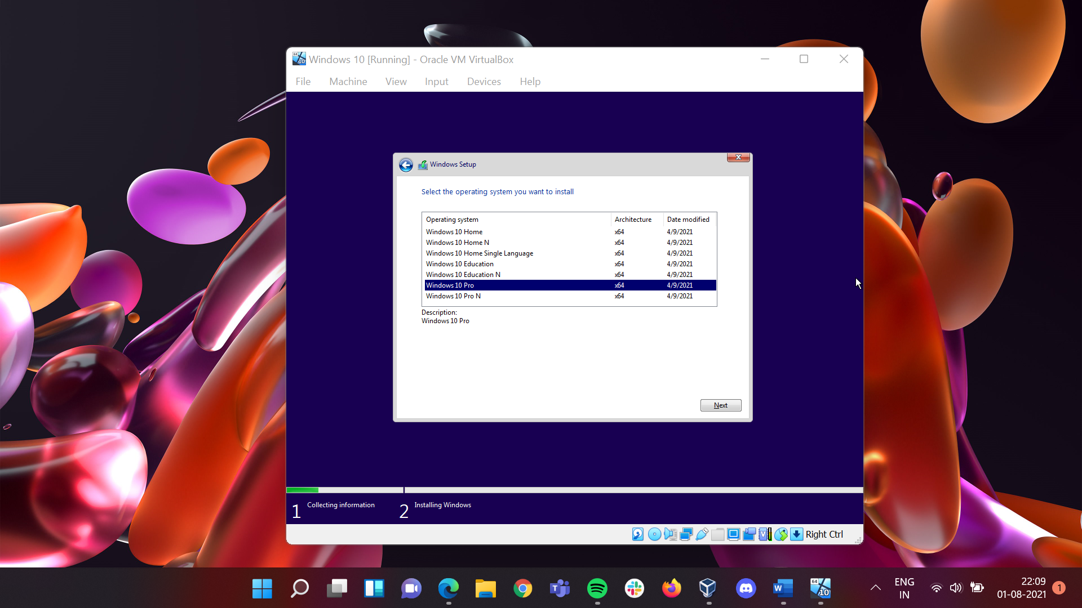

### Accept the **License Terms** and click on **Next** to proceed further.

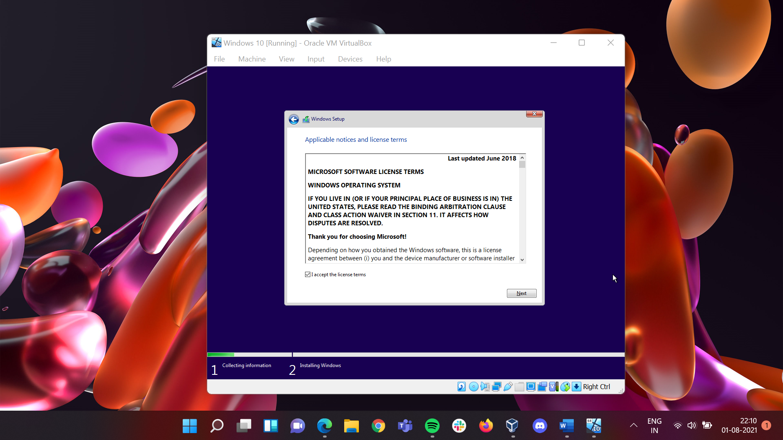

### Click on **Custom: Install Windows Only (Advanced)** to proceed futher

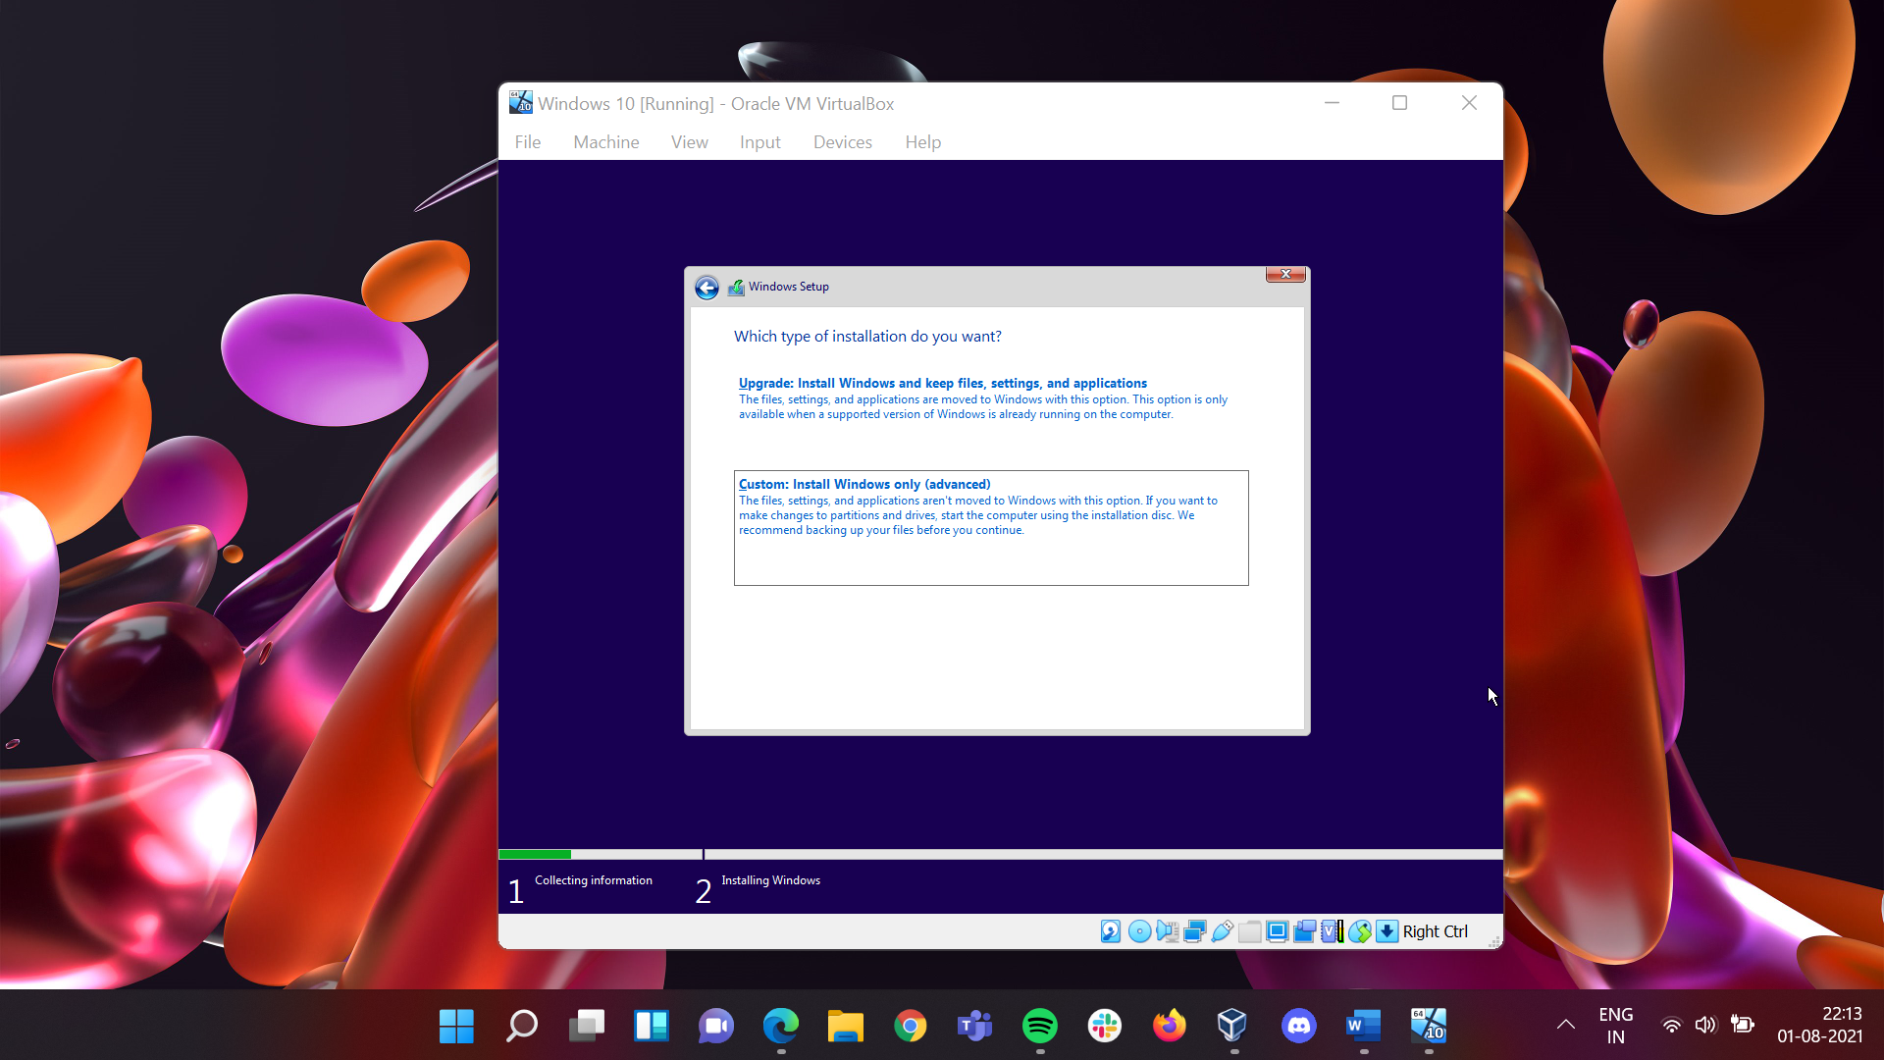

### Click on **Next** to proceed further

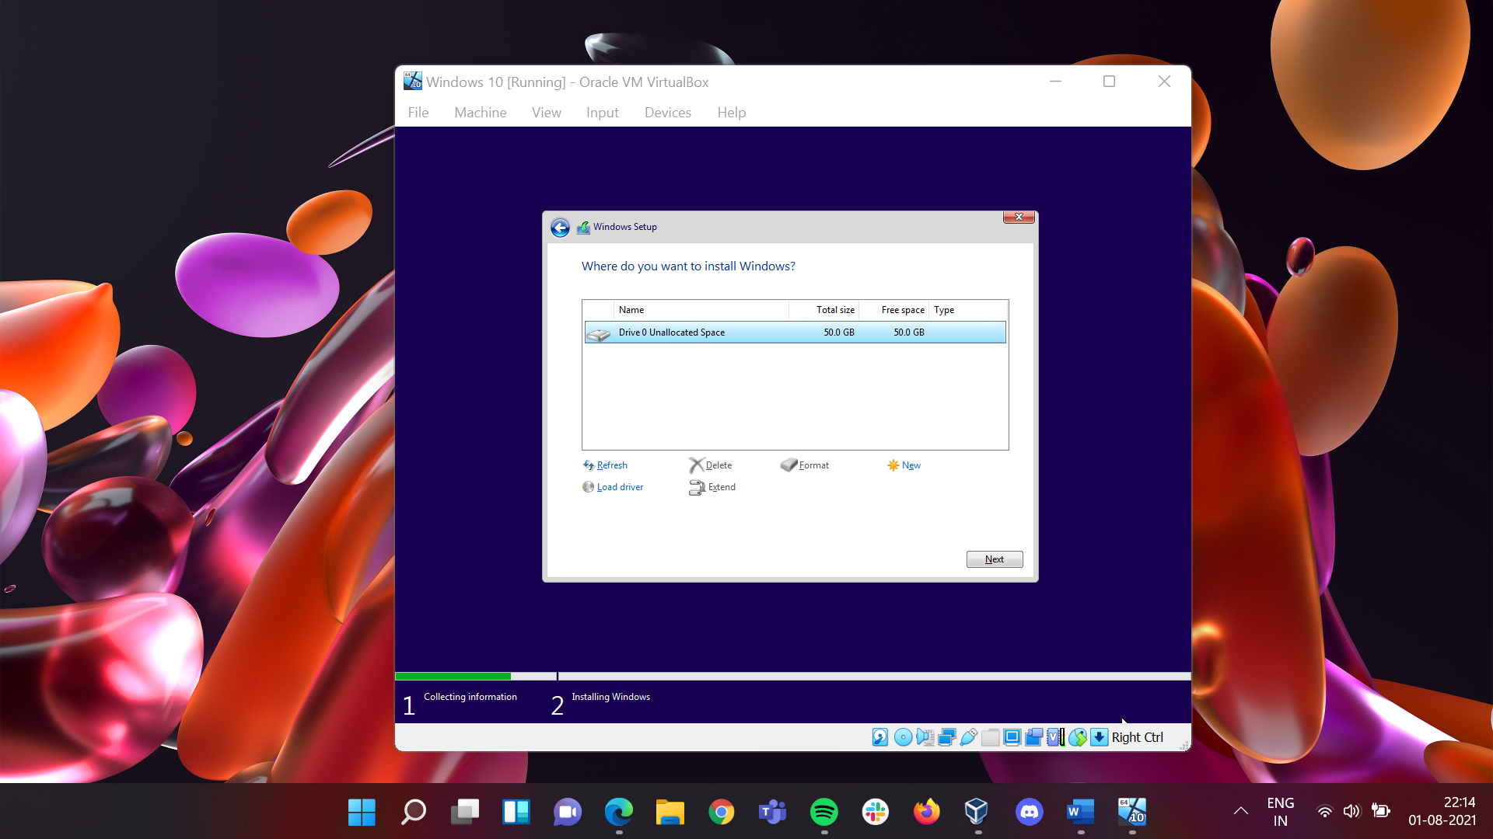

### The Installation process will start

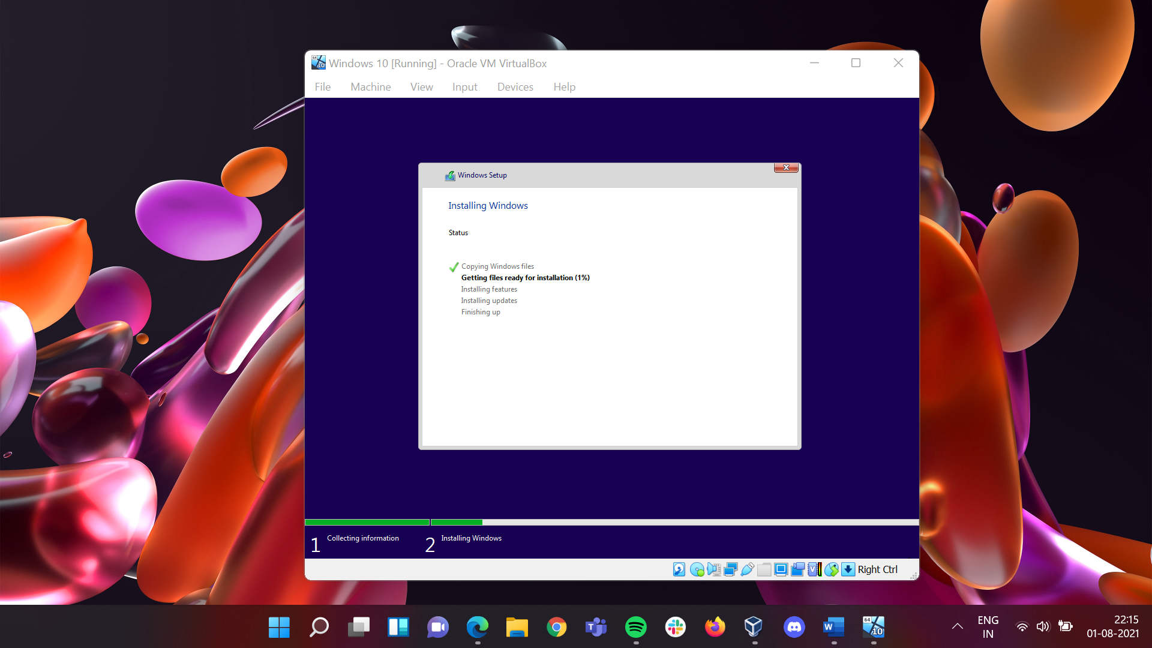

## **Since the installation is not being completed here, I will be using Kali Linux here**

## Now open the Oracle Virtual Machine

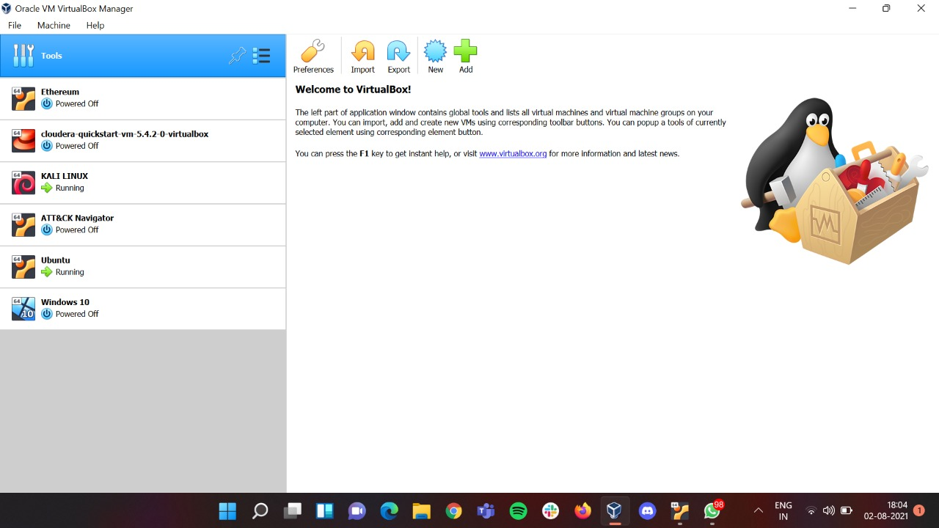

## Click on **Preferences** from the **Toolbar**.

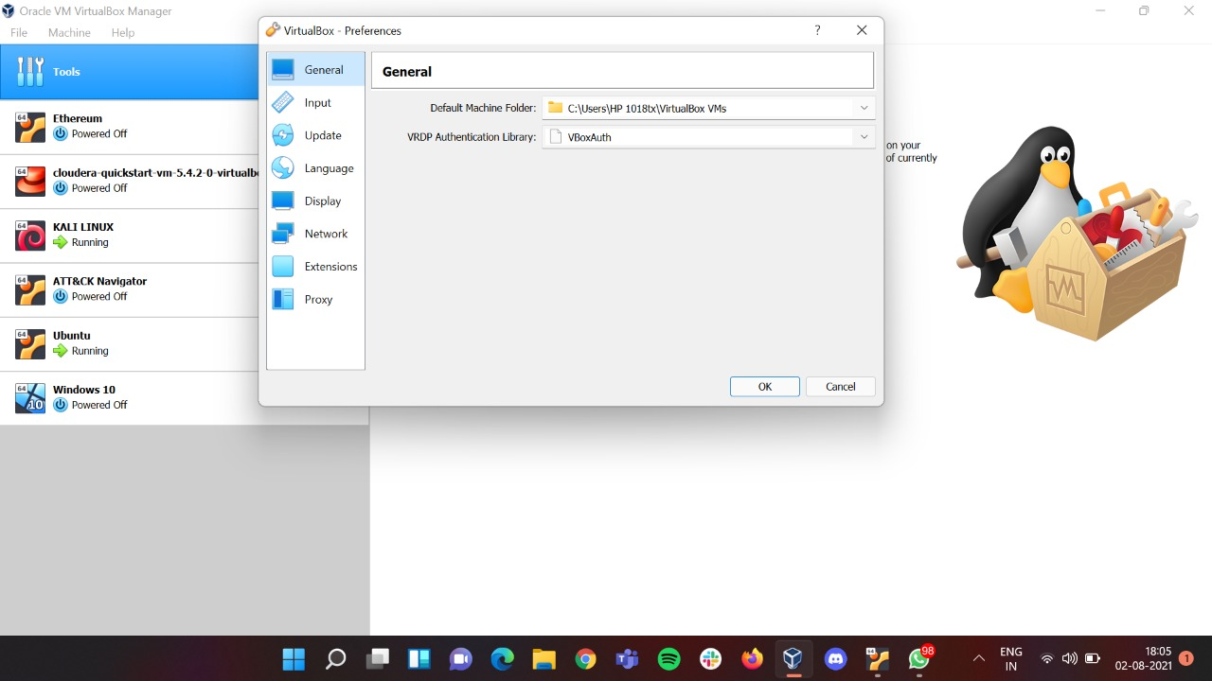

## Click on **Network.**

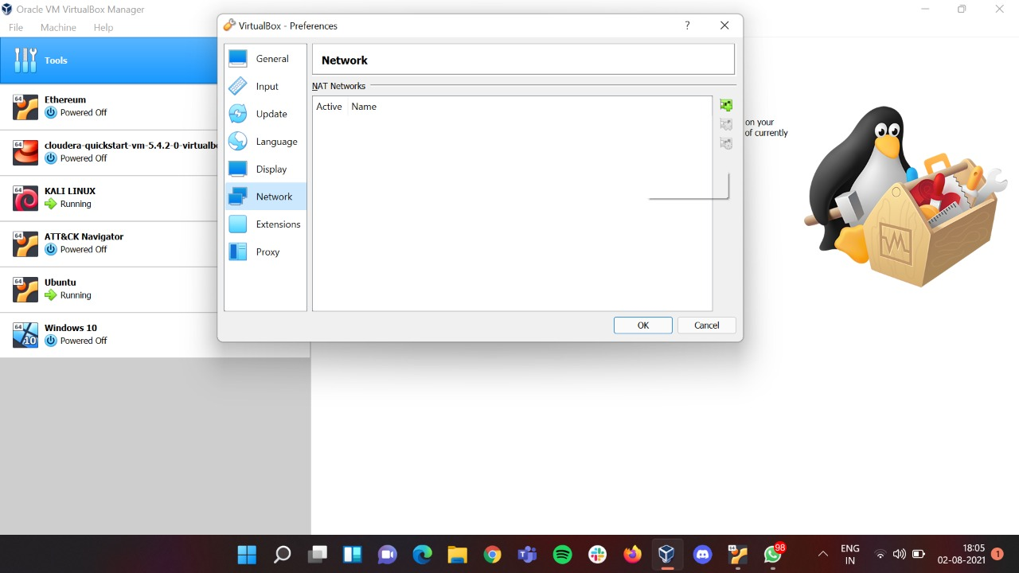

## Add a network there by clicking on icon

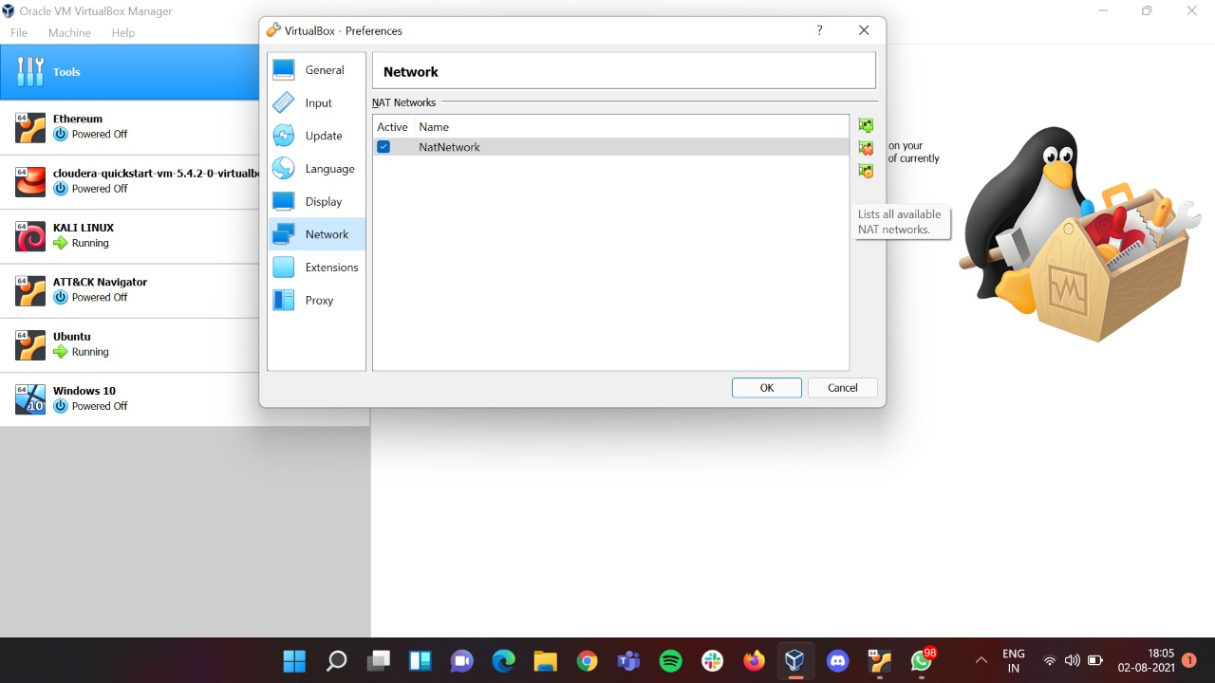

## Doble click on **NatNetwork** and change the **Network Name** to **vibrant_0810** and **Network CIDR** to **192.168.99.0/24** and then click on **OK** button.

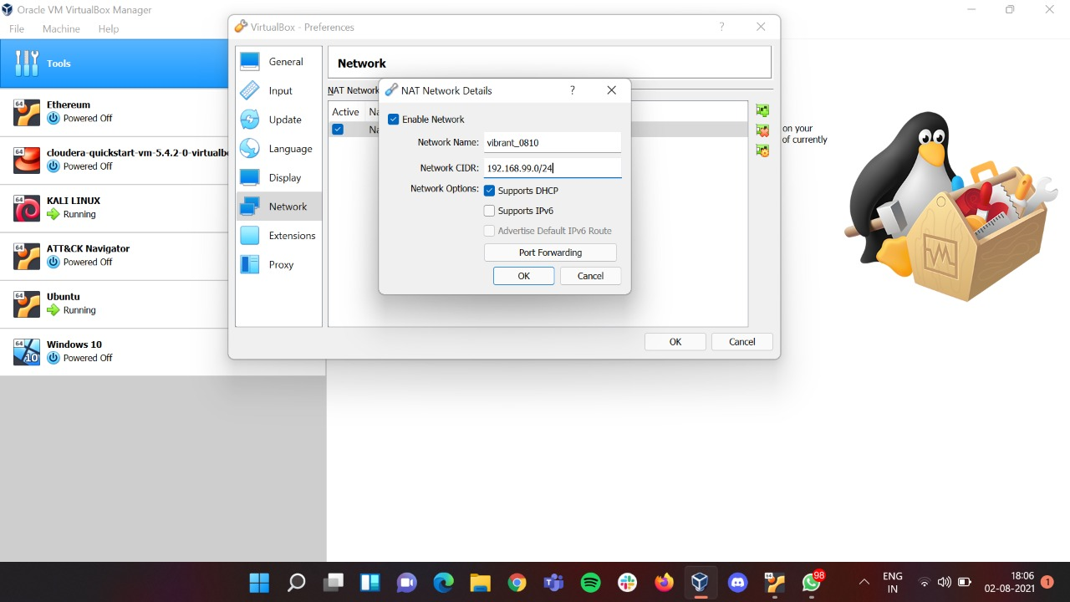

## After click on **OK** button, you can see the changed network name there. Click on **OK** button to proceed further.

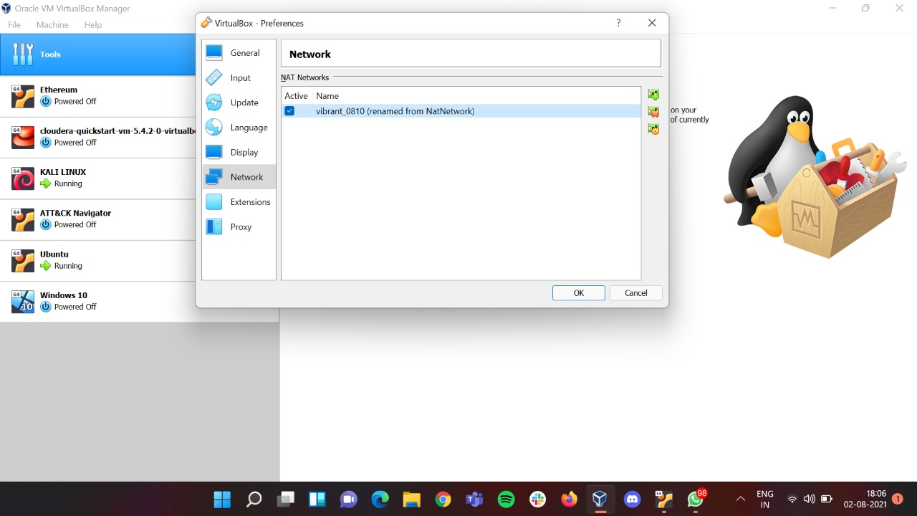

## Now open **Kali Linux** and **Ubuntu** windows side by side.

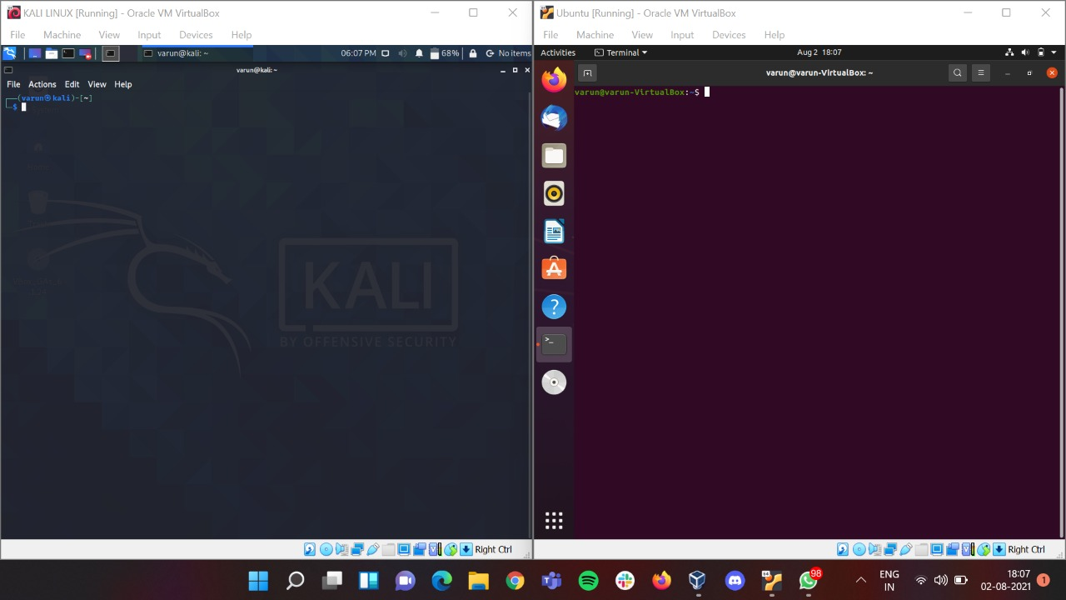

## Now will add the network added in Kali. To do that follow the steps below.

### From **Kali Linux Toolbar** click on **Machine** on that click on **Settings.**

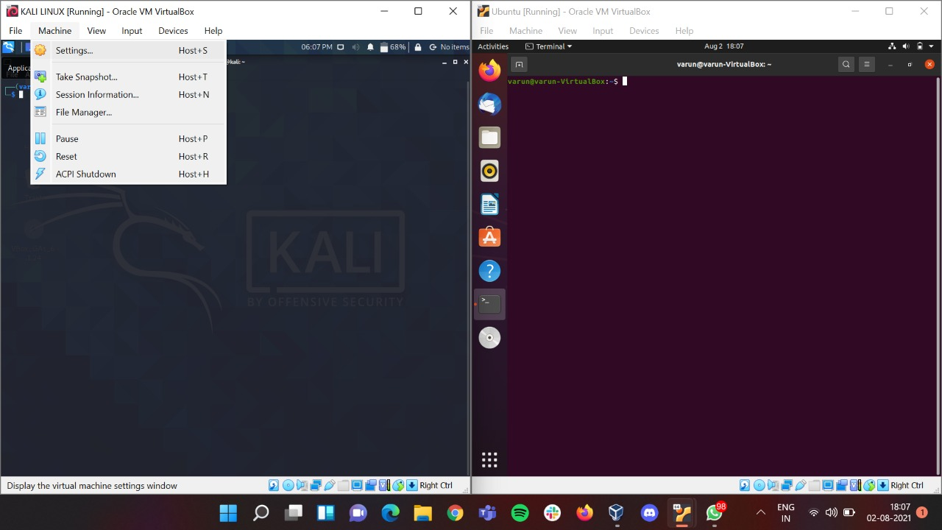

### Now the **Kali Linux Settings** window will open.

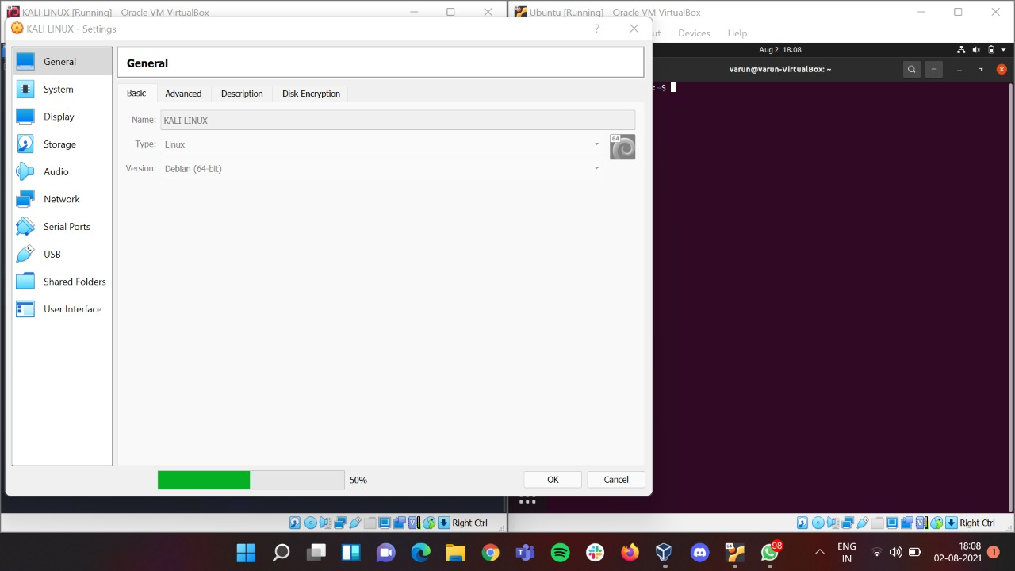

### Click on **Network** section

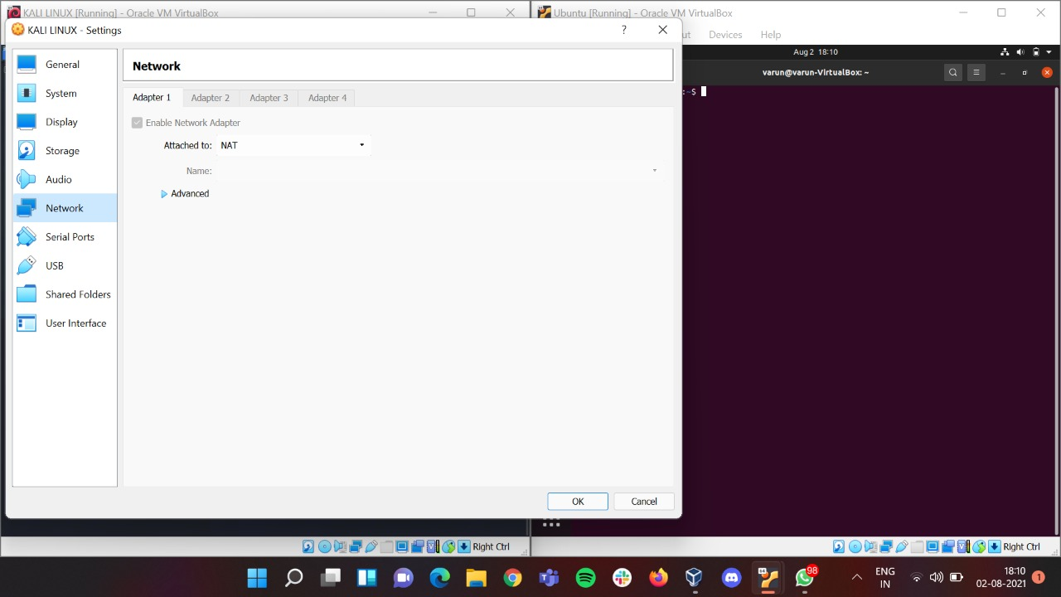

### After clicking on that from **Attached to** Dropdown box click on **NAT Network**

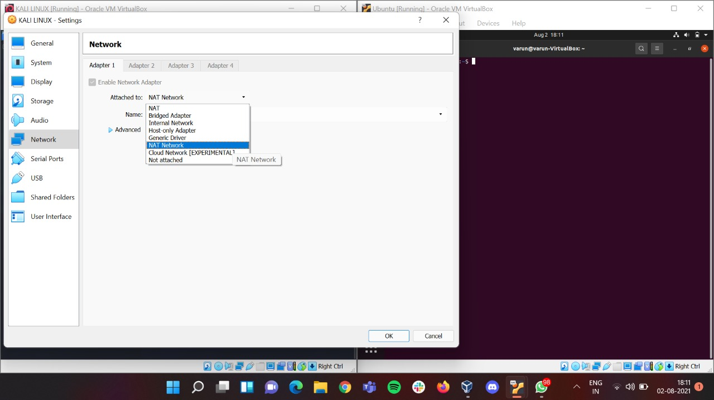

### After doing that click on **OK** Button to proceed further.

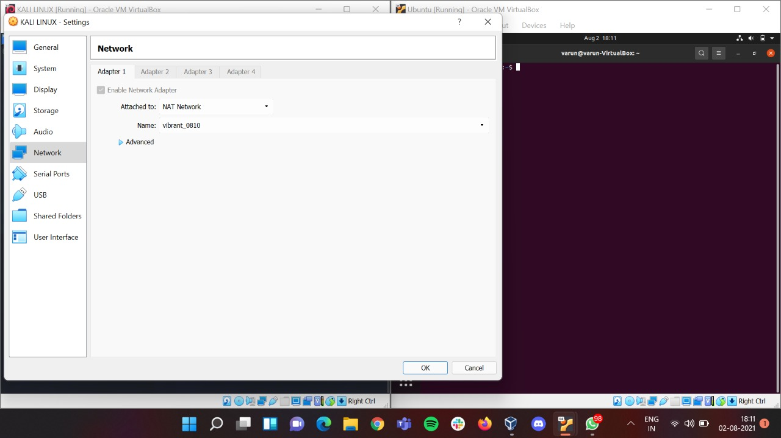

## Now will do the same in **Ubuntu**. To do that follow the steps below.

### From **Ubuntu Toolbar** click on **Machine** on that click on **Settings.**

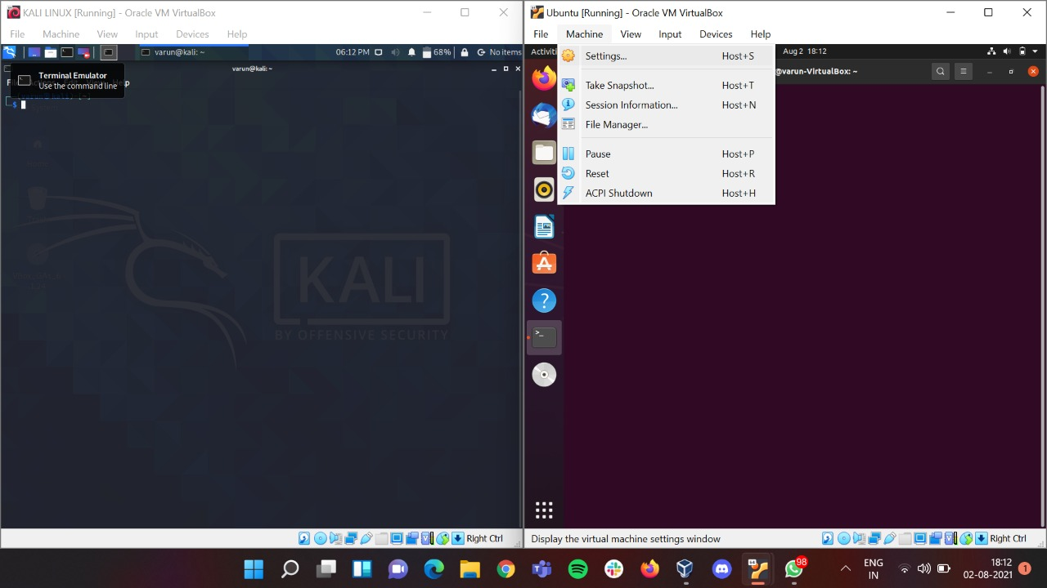

### Now the **Ubuntu Settings** window will open.

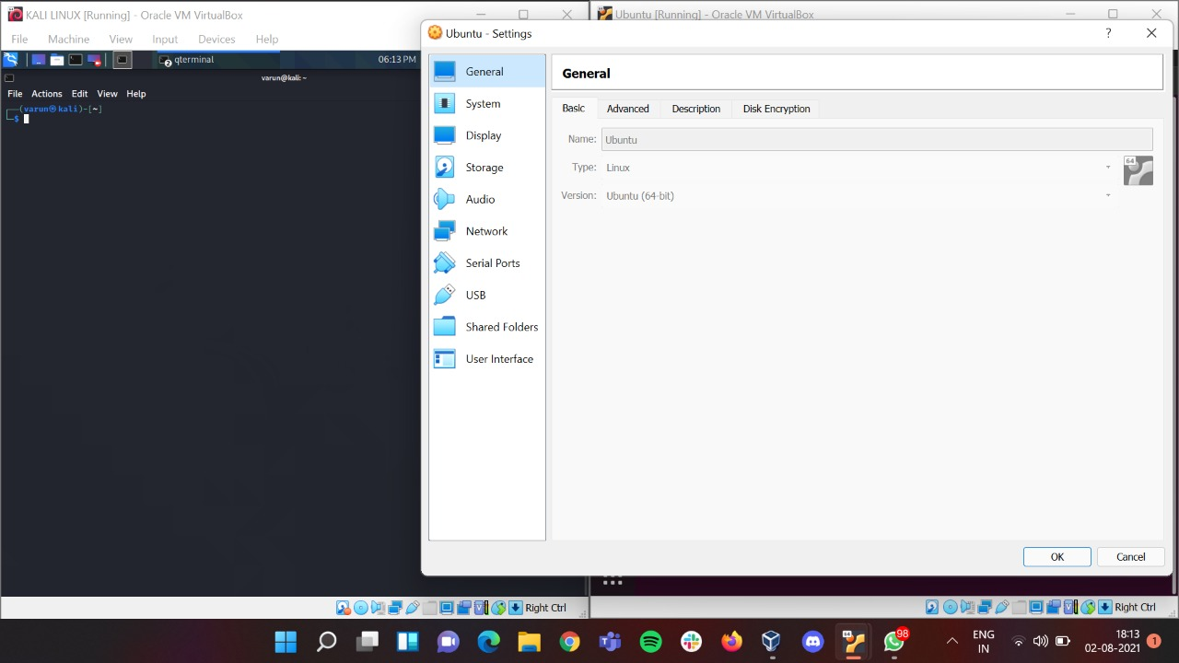

### Click on **Network** section

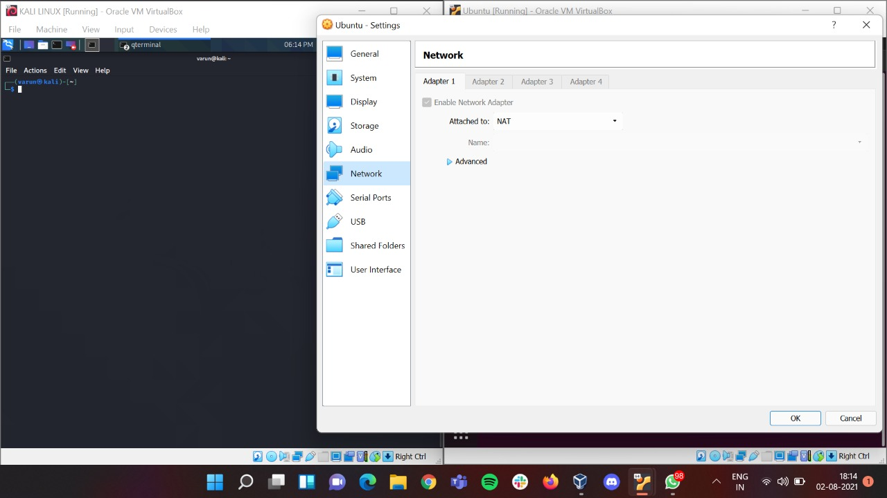

### After clicking on that from **Attached to** Dropdown box click on **NAT Network**

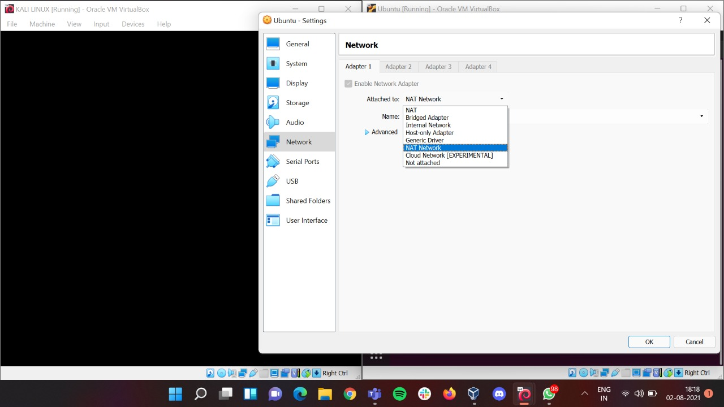

### After doing that click on **OK** Button to proceed further.

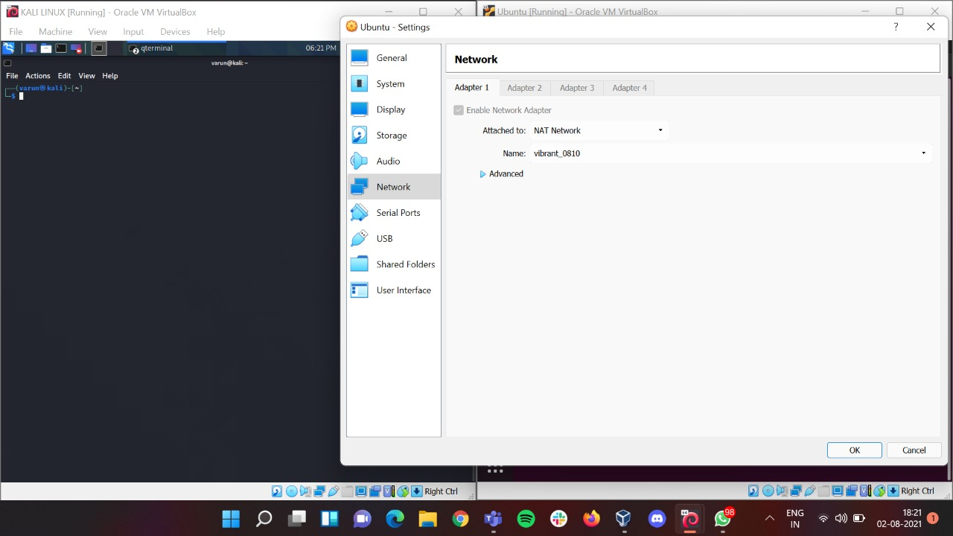

## Since now the added network is added in **Kali Linux** and **Ubuntu** follow the following steps now.

### Enter **ifconfig** command in both **Kali Linux** and **Ubuntu** and you will the below output and here you can check the new **IP Address** added viz **192.168.99.4 (Kali Linux)** and **192.168.99.5 (Ubuntu)**.

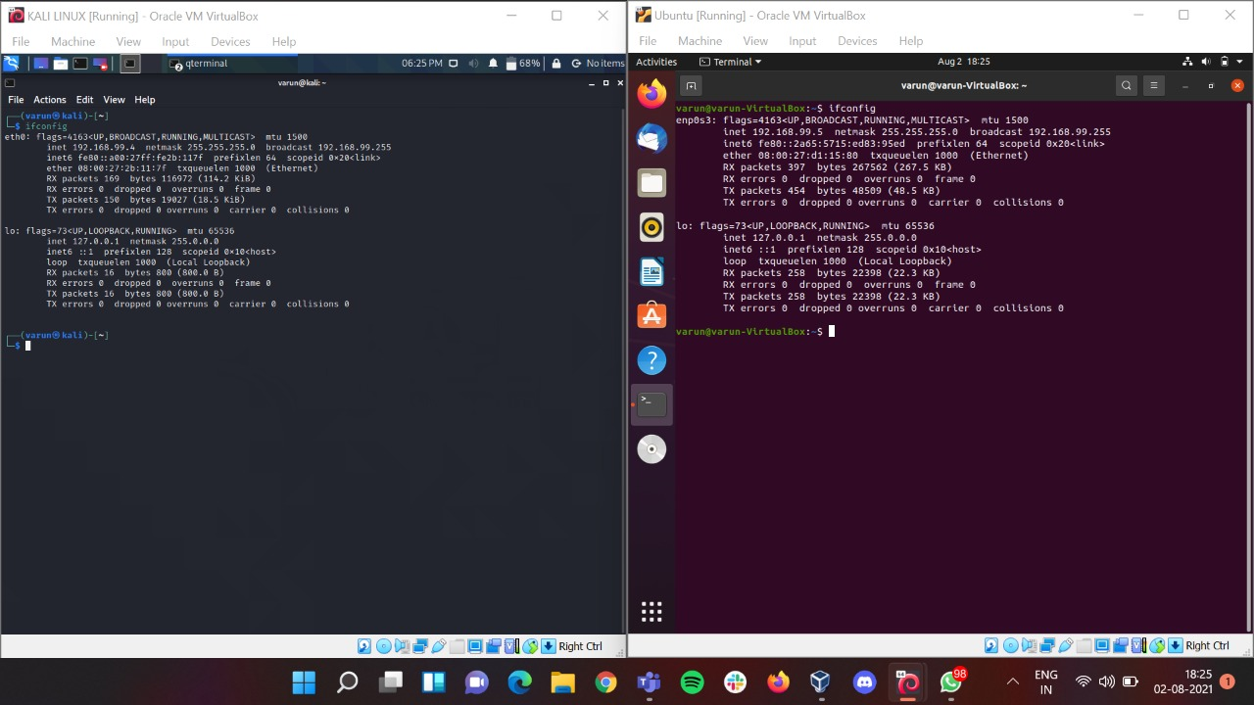

### Now enter **ping 192.168.99.5** command in **Kali Linux** to make it communicate with **Ubuntu Network.** Press **ctrl + c** to stop the sequence.

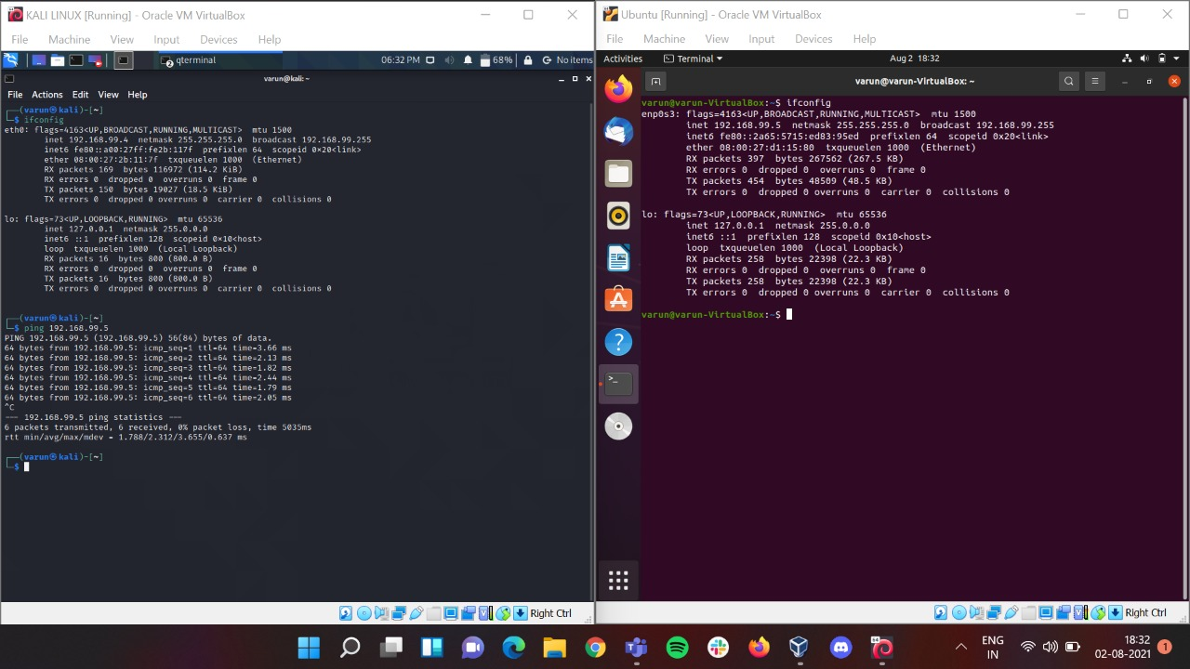

### Now enter **ping 192.168.99.4** command in **Ubuntu** to make it communicate with **Kali Linux Network.** Press **ctrl + c** to stop the sequence.

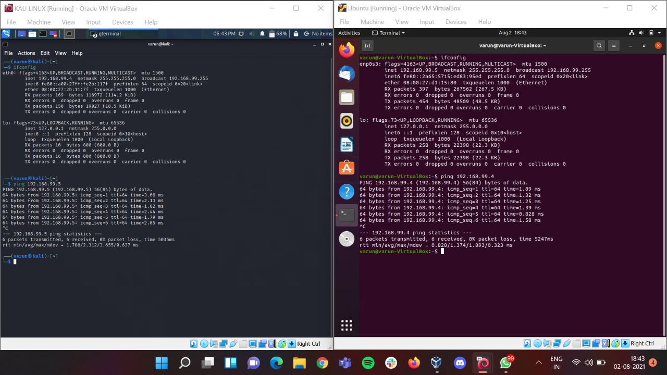

## Hence, we can make **Kali Linux** and **Ubuntu** communicate with each other

# Conclusion

Hence, we were able to install Windows 10/Kali Linux on VirtualBox and to make Windows 10/Kali Linux and Ubuntu communicate with each other.